|  |
| --- |
| e  TurnQuest Everest Insurance Suite  Human Resources Management System  Training Manual |

**Prepared By**



**AUGUST 2018**

Table of Contents

1 CORE SETUP 4

1.1 TYPES 4

1.1.1 TYPES DEFINITION 4

1.1.2 MASTER DEFINITION 6

1.1.3 EXPENSES 6

1.1.4 MEDIA SETUP 7

1.1.5 PROFESSIONAL BODIES 9

1.1.6 EXTERNAL ESTABLISHMENT 10

2.7 PERSONNEL MOVEMENT 112

2.7.1 MOVEMENT PARAMETERS 113

2.7.2 PERSONNEL MOVEMENT ELEMENT 114

2.7.3 PERSONNEL MOVEMENT 115

2.8 SUCCESSION PLANNING 117

2.8.1 SUCCESSION SETUP 117

2.8.2 SUCCESSION PERSONNEL SETUP 119

2.9 LEARNING AND DEVELOPMENT 122

3. PAYROLL 123

3.1 MASTER DEFINITION 123

3.1.1 ESTABLISHMENT DEFAULTS 123

3.1.2 GROUP DEFAULTS 124

3.1.3 PAY POINTS 124

3.2 PAY ELEMENTS RATES 125

3.3 PERSONNEL PAYMENT DETAILS 127

3.5 PERIODIC TRANSACTION 129

3.5.1 PAY ELEMENT WISE 130

3.5.2 CONTRACT WISE 131

3.6 PAYROLL PROGRESS 133

3.6.1 PRE-PROCESSING 133

3.6.2 PROCESSING 134

3.6.3 ROLLBACK 134

3.6.4 AUTHORIZATION 135

3.6.5 PAYSLIP INQUIRY 135

3.6.6 EMAIL PAYSLIPS 137

3.6.7 REPORTS 138

3.7 OFF PAYROLL PROCESSING 139

3.7.1 EN BLOCK PROCESSING 140

3.7.2 ROLLBACK ENBLOCK 140

3.7.3 EN-BLOCK PAYMENTS 141

3.7.4 EMAIL EN-BLOCK PAYSLIPS 142

3.8 LOANS 143

3.8.1 LOAN INTEREST RATES 144

3.8.3 EXTERNAL LOANS APPLICATIONS 145

3.8.4 LOAN MODIFICATIONS 145

3.8.5 LOAN SETTLEMENTS 147

3.8.6 REPORTS 148

3.9 SALARY ARREARS 149

3.9.1 PAY ELEMENTS 149

3.10 CONTRIBUTION/CUMULATIVE BALANCES 150

THIS IS THE LOGIN PAGE

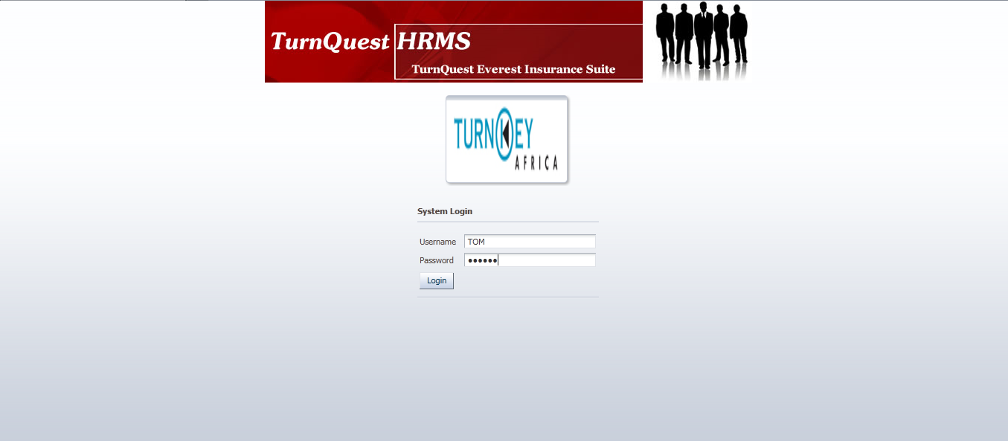

# 1 CORE SETUP

Used to define the basic setups for the whole system

## 1.1 TYPES

### 1.1.1 TYPES DEFINITION

Used to define basic types like addresses, dates, and schools etc for the use of the system

**Core setup >> types >> types definition**

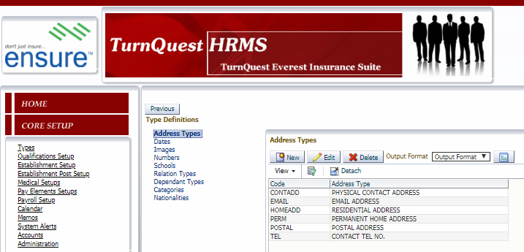And

Highlight the definition and select  and wait for window

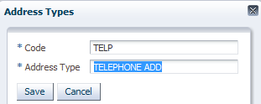 AND 

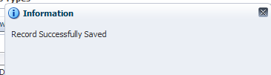

### 1.1.2 MASTER DEFINITION

Used to define more basic types like disabilities, ethnic origins,parametersetc

**Core setup >> types >> master definition**

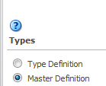And

Highlight the definition and select  and wait for window

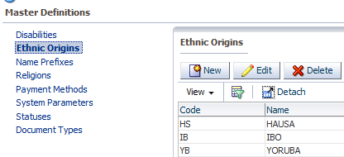

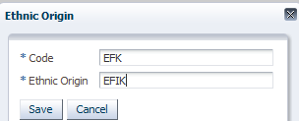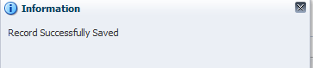

### 1.1.3 EXPENSES

Used to define other expenses

**Core setup >> types >> expenses**

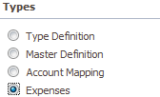And 

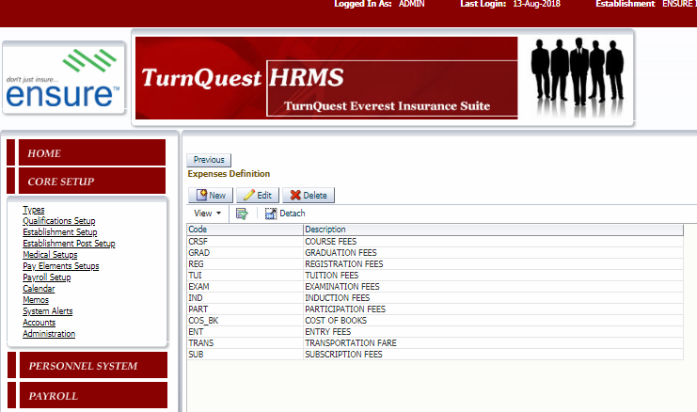

Select  and wait for window

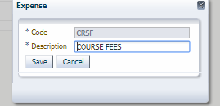 And 

### 1.1.4 MEDIA SETUP

Used to define the different media setup

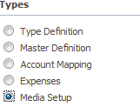 And 

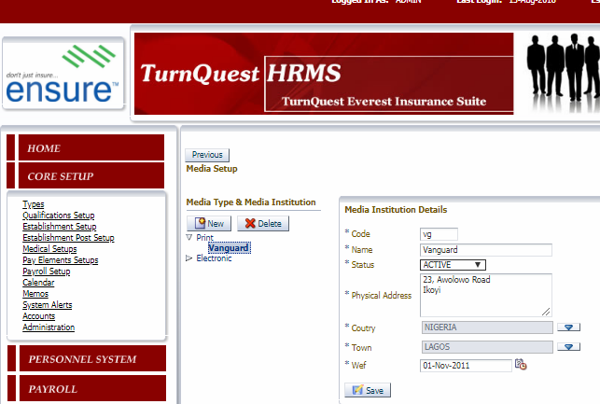

To define a new MEDIA TYPE, select  and wait for window

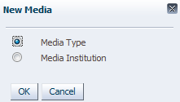AndIt clears the screen to input data

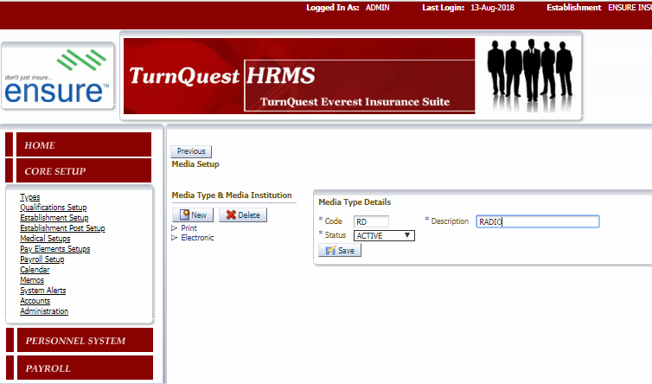 And 

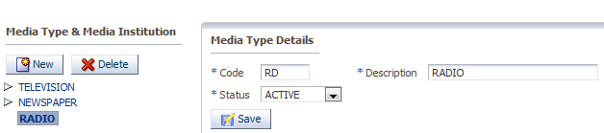

To define a MEDIA INSTITUTION, highlight the MEDIA TYPE and select  and wait for window

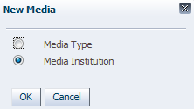 And 

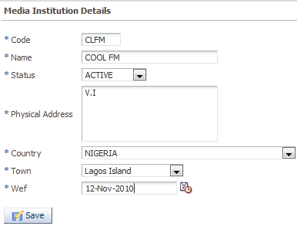And

### 1.1.5 PROFESSIONAL BODIES

Used to define professional bodies

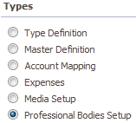 And 

Select  and wait for window. The screen clears to key details

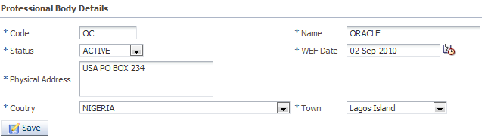

And 

--CERTIFICATIONS

Used to define certifications connected to the body

Highlight the PROFESSIONAL BODY, 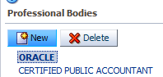 and go to CERTIFICATIONS

,

Select  and wait for window

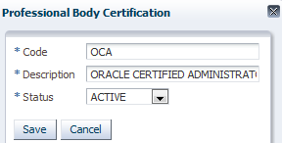 And 

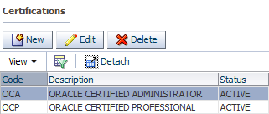

### 1.1.6 EXTERNAL ESTABLISHMENT

Used to define external establishment

**Core setup >> types >> external establishment**

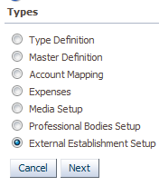>>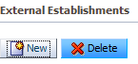 select  and wait for window

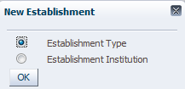 To define a new establishment type details

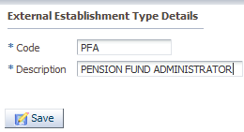 And 

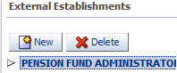

To define the ESTABLISHMENT INSTITUTION, highlight the ESTABLISHMENT TYPE and select 

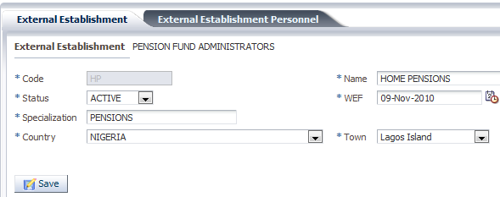

And 

To define [**External Establishment Personnel**](http://localhost:7001/HRMS/faces/extEstab.jspx?_adf.ctrl-state=12wfetzq6d_399) **,** select  and wait for window

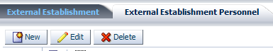

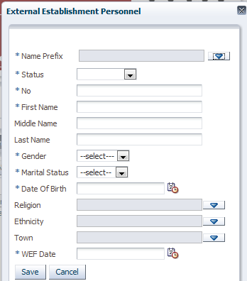

## 1.2 QUALIFICATIONS SETUP

Used to define the qualifications, where there are different levels. First define the **Qualification Category Groups**

**Core setup >> qualifications**

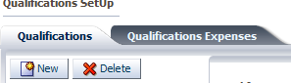

Select  and wait for window

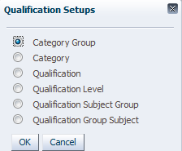>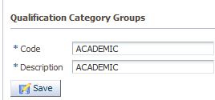 And 

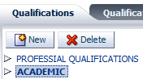

Now to define **Qualification Categories**, highlight the **Qualification Category Groups** and select >>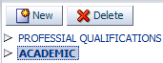>>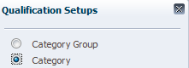>> and wait for window,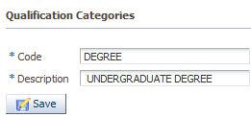 and >>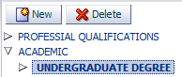

To define **Qualifications**highlight the **Qualification Categories,**

And select >>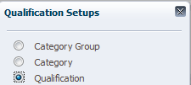>>

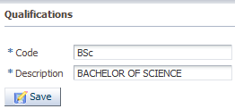And>>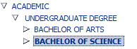

--GRADE

Used to define different grades. Mainly used during recruitment

Select  and wait for window



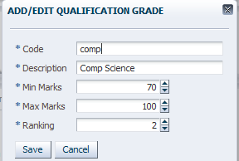

To define **Qualification Levels,** highlight the **Qualifications** and select

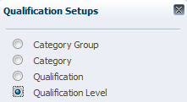

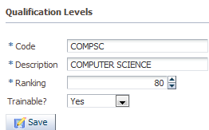>>>>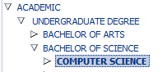

**--**[**Qualifications Expenses**](http://localhost:7001/HRMS/faces/qualifications.jspx?_afrLoop=4352902531734&_afrWindowMode=0&_adf.ctrl-state=16zatmdz2n_14)

Used to define the qualification expenses

Pick the **qualification**

>>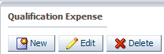

Select  and wait for window

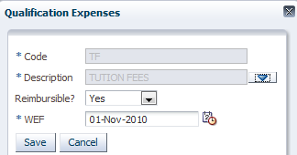 And 

--**Qualification Level Expenses**

To define the qualification level expense

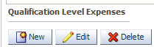>> Select  and wait for window

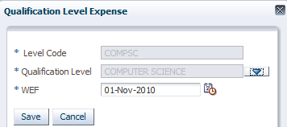

## 1.3 ESTABLISHMENT SETUP

Used to define setups for the organization

**--** [**Unit Levels**](http://localhost:7001/HRMS/faces/estabDefn.jspx?_adf.ctrl-state=16zatmdz2n_34)

Used to define the different level of the organization



Select >>

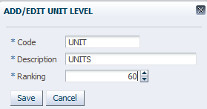

**--ESTABLISHMENT DEFINITION**

Used to define the **establishment/organization**

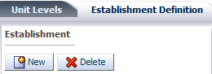>>>>

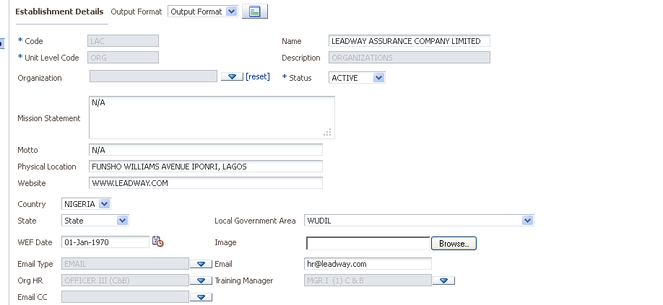

Code = code of organization

Name = name of the organization

Status = active

Mission statement = mission statement of the organization

Country = the country

State = the state of the organization

Local government area = the LGA

ORG HR = the Head of HR of the organization

Training manager = the training manager of the organization

Image = the image of the organization

**--** [**Sub-Divisions**](http://localhost:7001/HRMS/faces/estabDefn.jspx?_afrLoop=5743941372979&_afrWindowMode=0&_adf.ctrl-state=16zatmdz2n_44)

Used to define the administration of the organization

 Select  and wait for window, it clears the screen to key in details

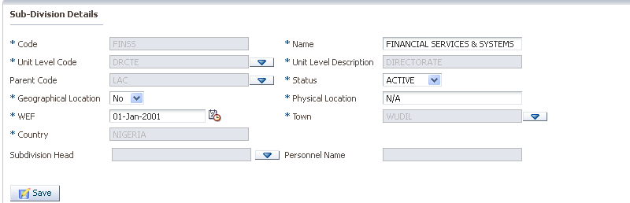

And 

Unit level = level previously defined but this is a division level

Status = active

Geographical location if it is a functional not location

-**-** [**Regions and Branches**](http://localhost:7001/HRMS/faces/estabDefn.jspx?_adf.ctrl-state=16zatmdz2n_44)

Used to define the regions and branches

>> select 

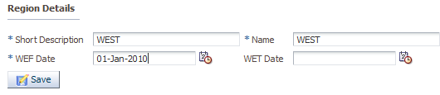

And 

**Branches**

To define the branches, highlight the region

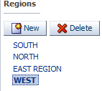>>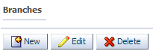

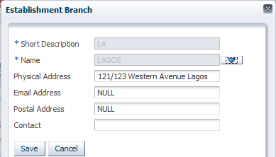 And 

**--CADRES**

Used to define the different **Establishment Groups.**

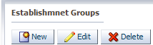>> select >>

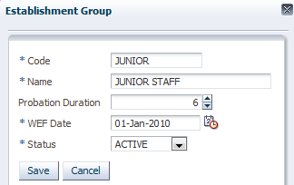 AND 

**--** [**Panels**](http://localhost:7001/HRMS/faces/estabDefn.jspx?_afrWindowMode=0&_afrLoop=7320048140696&_adf.ctrl-state=16zatmdz2n_49)

Used to different panels and members of the panel

Select  and fill out the details

 And save

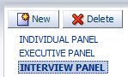

**Panel Members:** to define the different members under the panel

Highlight the panel, and  select 

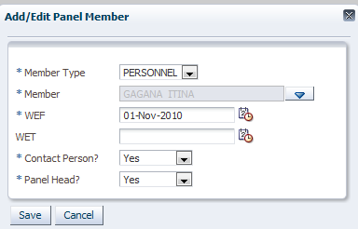

Member type = personnel or a particular post

Member = updates after member type is picked, thus is picked from drop down

Panel head = if the person is the panel head

**--** [**Interview Levels**](http://localhost:7001/HRMS/faces/estabDefn.jspx?_adf.ctrl-state=16zatmdz2n_64)

To define the different interview levels

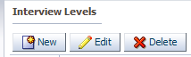>> select >>

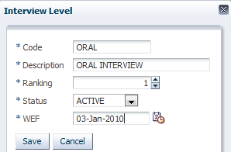 And 

## 1.4 ESTABLISHMENT POST SETUP

Used to define the various post levels, post and pay grade

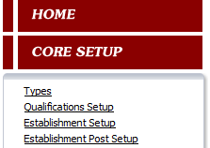

**--**[**Post Levels & Grade Details**](http://localhost:7001/HRMS/faces/estabPostsSetUp.jspx?_adf.ctrl-state=18er77kpe3_14)

Used to define the post levels and their grade

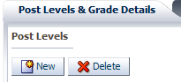>>>>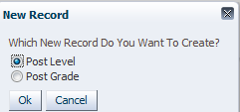>>

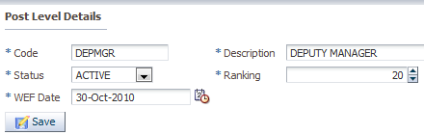 And 





--POST GRADE: used to define the different grade levels for this post level.

Highlight the **post level,** and**>>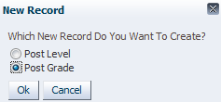>>**

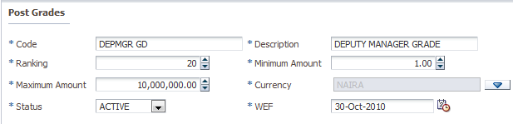

And >>.

[**Grades Differential**](http://localhost:7001/HRMS/faces/estabPostsSetUp.jspx?_adf.ctrl-state=18er77kpe3_14)

Used to define the different grades basic pay. In this case, we want a grade level of 1 to 14. Each grade has different amounts, but their differential amount could be the same which is the case here.

>>>>

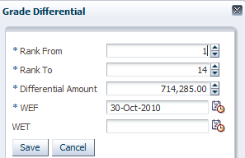>>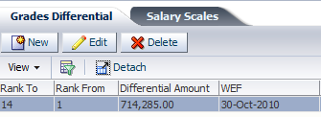

**--**[**Salary Scales**](http://localhost:7001/HRMS/faces/estabPostsSetUp.jspx?_adf.ctrl-state=18er77kpe3_14)**:** used to define the salary scale per grade level per post level

Note: it can be done automatically where we take into consideration the grade differential set earlier or manually by keying in details manually



To automatically do it, just  and populates details

Or manually  and wait for window. But in this case it is been done automatically

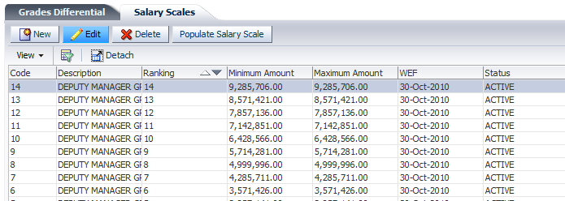

**--**[**Definitions**](http://localhost:7001/HRMS/faces/estabPostsSetUp.jspx?_adf.ctrl-state=18er77kpe3_14)

Used to define the various post per post level

Highlight the post level and >>

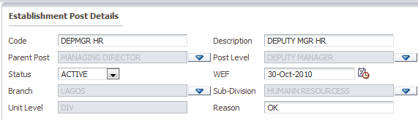

Description = name of the post

Parent post = referred to as senior post. The person this post reports to. I .e immediate senior

Post level = the post level this post belongs to

Sub division = the sub division it belongs to

And 

--POST QUALIFICATION

Used to define the qualifications this post is supposed to have. This is used during succession planning and employment

Select  and fill out the details

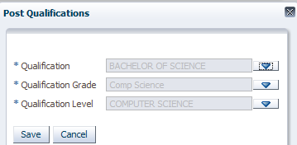

**--** [**Pay Element Grade Details**](http://localhost:7001/HRMS/faces/estabPostsSetUp.jspx?_adf.ctrl-state=18er77kpe3_14)

Used to define the pay elements per post level. This is used when employing a personnel, it automatically takes this pay element amount

Highlight the post level and >>

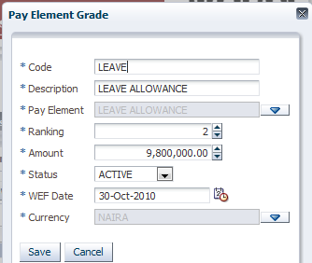 And 

## 1.5 MEDICAL SETUPS

Used to define the medical setups

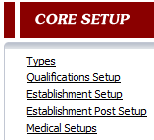

**1.5.1 SERVICE DEINITION**

Used to define the medical service group and medical service

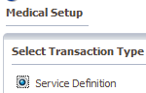>>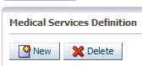>>>>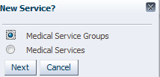>>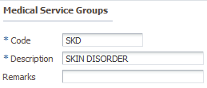>>

**--MEDICAL SERVICE**

To define the medical service, highlight the **GROUP** and 

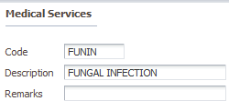>>

**1.5.2 INSTITUTION DEFINITION**

Used to define the different medical institution

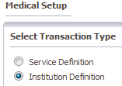**>>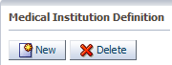>>>>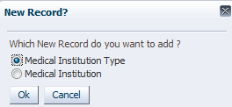>>>>**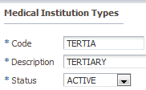

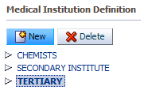

To define the medical institution, highlight the medical institution type and >>

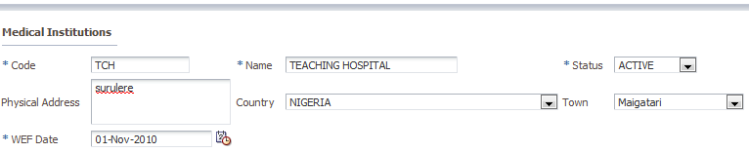

And save

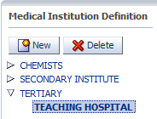.

**--**[**Service Groups**](http://localhost:7001/HRMS/faces/medicalDef.jspx?_adf.ctrl-state=96xgiquhp_109)

Used to define the service groups under the medical institution defined earlier

>>

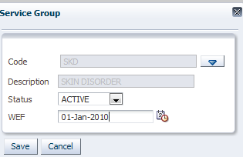 Picked the SKD defined earlier and 

**--**[**Group Services**](http://localhost:7001/HRMS/faces/medicalDef.jspx?_adf.ctrl-state=96xgiquhp_109)

Used to define the medical services for the institution. To create a new one, highlight the SKIN DISORDER defined in the SERVICE GROUP, under the GROUP SERVICE select >>

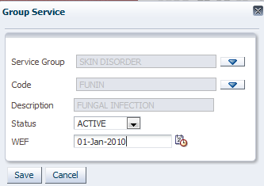>>

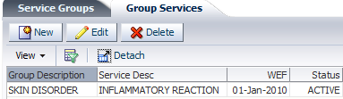.

## 1.6 PAY ELEMENT SETUPS

Used to define the pay element and assign to different groups

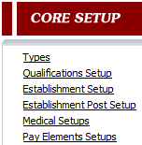

### 1.6.1 PAY ELEMENTS DEFINITION

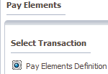>>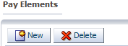>>>>

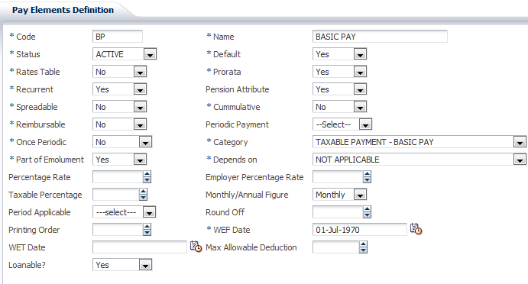

**Name** = name of pay element

**Status** = active or not

**Rates table** = if the pay element uses rate table

**Spreadable** = if the pay element should be paid after leaving the company

**Once periodic** = if the pay element should be paid once in a specified period

**Part of emolument** = if this element is part of pension

**Percentage element** = if this element depends on another pay element, what percentage depends on it

**Period applicable** = if it is once periodic, this defines which period should this be applicable

**Prorate** = if pay element is prorated

**Pension attribute** = if pay element is part of pension

**Cumulative** = if pay element is like a contribution and accumulates until owner is ready to leave the company

**Periodic payment** = pay elements that are paid like once/ twice a year, this defines if once or twice

**Category** = the category the element depends on. E.g. tax, cash benefit, taxable pay element etc

**Depends on** = if the pay element depends on another, define the other e.g . insurance relief which depends on premiums.

**Employer rate** = if this pay element has a percentage where the employer drops a part of it

**Monthly/ annual figure** = this should be monthly, the amount we define in the pay elements are annual figures, so if monthly, it takes the figures and divides by 12 and distribute equally during payroll

For Loans the following additional fields are applicable;

**Minimum instalments**= the minimum payable instalments per loan

**Maximum instalments=**the maximum number of instalments payable per loan

**Repayment Grace Period**=

### 1.6.2 GROUP PAY ELEMENTS

Used to attach pay elements already defined to the different groups

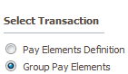>>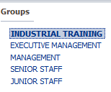 highlight the GROUP >>

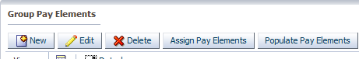

 = to populate all pay elements defined

 = used to assign the pay elements to all individuals to that group

 = used to key in details one by one.

### 1.6.3 PERSONNEL PAY ELEMENTS

Used to assign the pay element to personnel

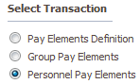>>>>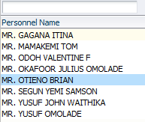>>

Highlight the personnel >>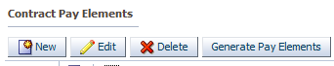

 = to generate pay element to the personnel

 = to key in details one by one

NOTE: Only Recurrent pay elements except BASIC PAY cannot be altered because upon recruitment, it automatically takes the ANNUAL BASIC PAY assigned to the post.

All personnel pay elements can be viewed from this screen with their values.

## 1.7 PAYROLL SETUP

Used to define the different payrolls

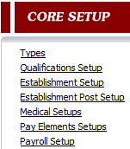

### 1.7.1 FREQUENCIES

To define the frequencies the payrolls are to be run

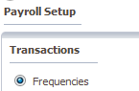>>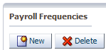>>>>

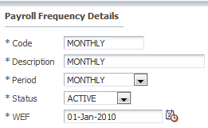>>

### 1.7.2 DEFINITIONS

Used to define the different types of payroll for the organizations.

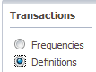>>>>

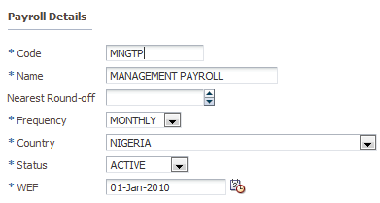>>

### 1.7.3 PERIODS

Used to define the periods for which the payroll will be run.

Select the country, year and payroll that u want to generate periods for;

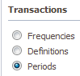>>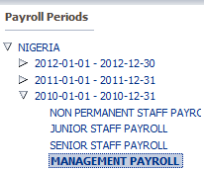>> drop down to the payroll defined click on

 = to auto generate the periods, all left is to edit to define **Processing Date**, Pay **slip Date** and **Payment Date**

Highlight the period and 

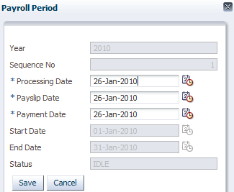>>

## 1.8 CALENDER

Used to define the calendar

Core setup >> calendar

>> select >>

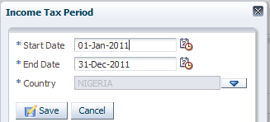>>

After defining the years, then the holidays during this year.

Highlight the **year** just defined >>

>>>>

Select >> and add the holidays in the specific year/period selected.

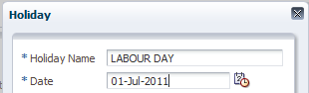>>

## 1.9 MEMOS

Used to define the various types of memos to be used

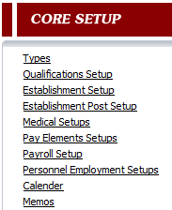>>>>>>

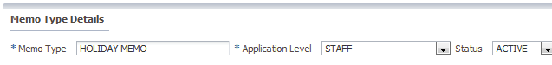

And 

**MEMO SUBJECT**

Used to define the subject of the memo.

Click on new button add the details of the memo subject and save.

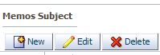>>>>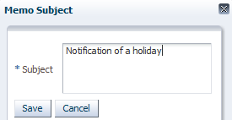

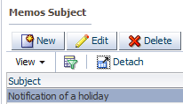

**MEMO CONTENT**

Used to define the content of the memo

Click on new add the memo content and click on save

>>>>

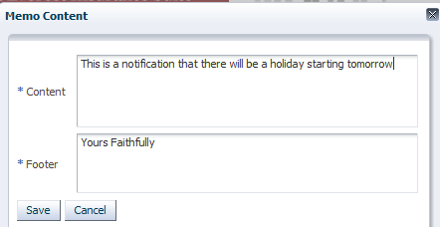

And.

## 1.10 SYSTEM ALERTS

Used to define various **alert recipients** in caseof transfer and termination of employees

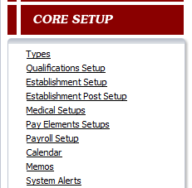>>highlight a module >>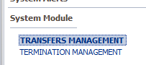

Move to the right hand side >>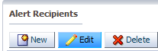>> select >>

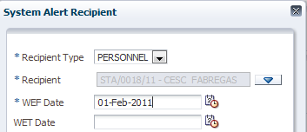

Recipient type = it could be a **personnel, group** or **post**

Recipient = picked from a **LOV,** which is populated after picking the **recipient type**

WEF = with effect from date.



## 1.11 ACCOUNTS

Used to define the various interactions between **HRMS** and **FMS.**mapping of GL accounts

Core setup >> accounts

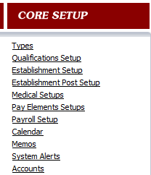

### 1.11.1 ACCOUNT MAPPING

**>>>>**

Used to attach different transcation types to GL accounts e.g. loans, staff recreation

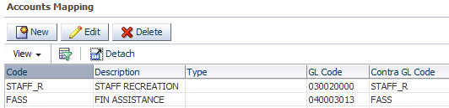

Select  and wait for window

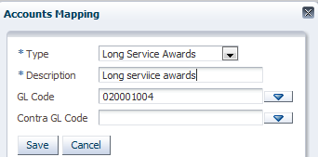 And 

Type = type of transaction

Description = description of the transaction or expense.

GL code = the GL account to be effected when the transaction is posted to Finance for this expense

### 1.11.2 GENERAL LEDGER INTERFACE

Used to attach GL accounts for all in the payroll pay elements

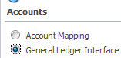>>>>

Click on the button >>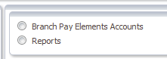>> it brings out a new screen

Select the pay element, status, branch and control accounts. Add the WEF date and click on save.

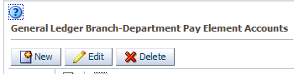>> select >>

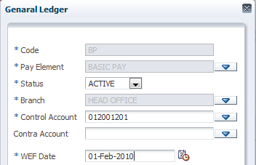>>.

## 1.12 ADMINISTRATION

Used to define roles and approvals areas.

Core setup >> administration

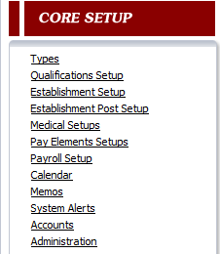>>

### 1.12.1 HR APPROVAL SETUP

>>>>

This is used to setup approvals per system areas

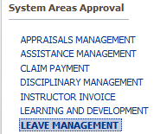 Highlight the area to set up

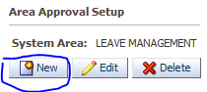

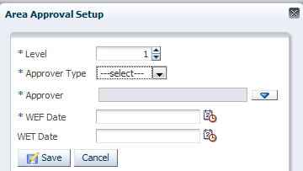

**Level** = Input the level

**Approver type** = post, rank, personnel

**NOTE: the approver type drives the approver**

**Approver =** after selecting the approver type, the LOV of approver is populated

**WEF =** with effect from

**Approver type**

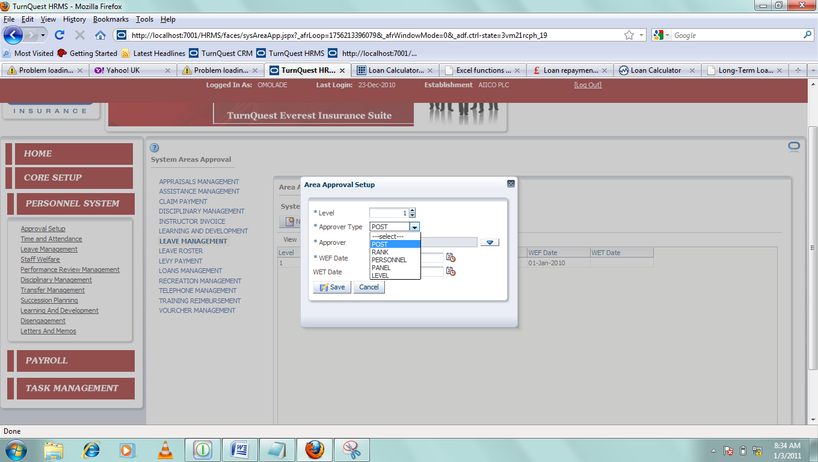

Post = to pick a post that has been defined

Personnel = to pick a personnel

Panel = to pick a panel which is defined in the system

Rank = to pick a post a personnel reports to directly

### 1.12.2 ROLE SETUP

Used to define the different roles for running of payroll

>>>>>> select  . On the right hand side, it clears

The screen >>

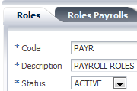 And.

**ROLES PAYROLL**

This is used to define **payrolls roles.**

On the left hand side, highlight the **role** just created.

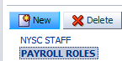>>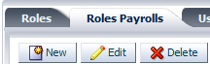>> select >>

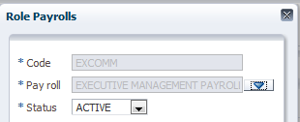

Payroll = used to pick the payroll

Status = if active

And.

After defining the **payroll,** then define the **personnel** under that payroll

Highlight the **payroll**

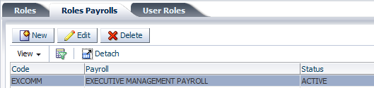

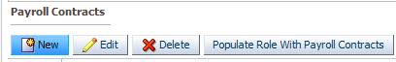

To auto populate personnel’s under this payroll, just 

To auto populate

or

Select  and pick the**personnel**

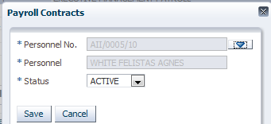

>>

**USER ROLES**

After creating roles, it is time to attach those roles to personnel to have the authorization of running payroll

Highlight then **payroll role**

>>>>

Highlight the personnel >>

>> Then below

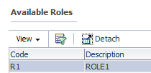>> To move that role to the **highlighted personnel**

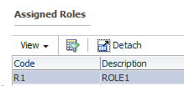

# 2. PERSONNEL SYSTEM

## 2.1 PERSONNEL RECRUITMENT

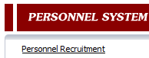

### 2.1.1 VACANCIES DEFINITIONS

Used to define and declare vacant posts

Select the menu item and click on next >>**>**>

To define a new vacancy click on new a window pops up as shown below >>>>

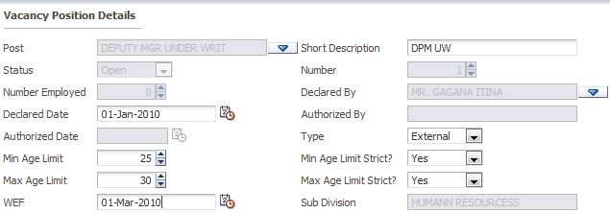

Post = select post to be declared vacant

Declared by = person to declare the post available

Min Age Limit Strict = if there is a restricted age limit

Min Age Limit = if there is a restricted age limit, then what age

Max Age Limit Strict = if there is a restricted age limit

Max Age Limit = if max age limit is restricted, then what age

And 

Other details can be added for this post:

Below other details can be captured by

[**Vacant Position Panel Members**](http://localhost:7001/HRMS/faces/vacanciesDefns.jspx?_adf.ctrl-state=5ya0pyanr_59) **= interview panel** members for the position

>>>> and picking a personnel and saving

>>.

[**Vacant Position Duties**](http://localhost:7001/HRMS/faces/vacanciesDefns.jspx?_adf.ctrl-state=5ya0pyanr_59) **=** duties for the position

>> select  and add duties applicable to that position

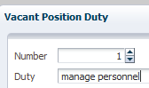fill details and .

[**Vacant Position Criteria**](http://localhost:7001/HRMS/faces/vacanciesDefns.jspx?_adf.ctrl-state=5ya0pyanr_59) **=** criteria for the position

Click the **tab**>> select >>

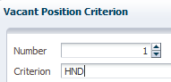>>

### 2.1.2 VACANCIES ADVERTISEMENTS

Used to advertise the vacancies that have been declared vacant

>>>> from the drop down arrow, highlight the **post**

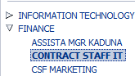

On the right hand side,

>> select >>

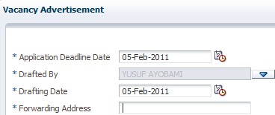

Application deadline date = application deadline date

Drafted by = personnel who drafted the **post.**

Drafting date = the date it was drafted

And.

After capturing the vacancy **advertisement,** below the vacancy advertisement

**Advertisement media** used to capture the media.

### 2.1.3 VACANCIES QUALIFICATIONS DETAILS

Used to capture qualification details.

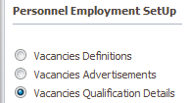>>>>

Highlight the post >> >>>>

The screen below will be displayed

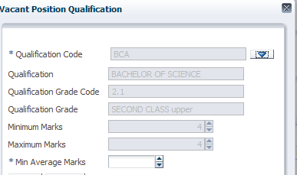>>

Qualification code = picked from a **drop down**

**Min average marks**= input the minimum marks you expect from the vacant position qualification.

### 2.1.4 VACANCIES APPLICATIONS

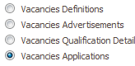>>>>

Used to capture details of shortlisted candidates

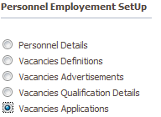>>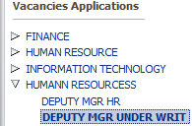>>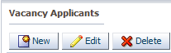>>>>

Select the name prefix, input the first name and last name of the applicant, select the gender, marital status, date of birth, application date and receipt date and click on save.

Records can only be saved when all mandatory field have been field the other fields like salary expectations and email addresses can be added.

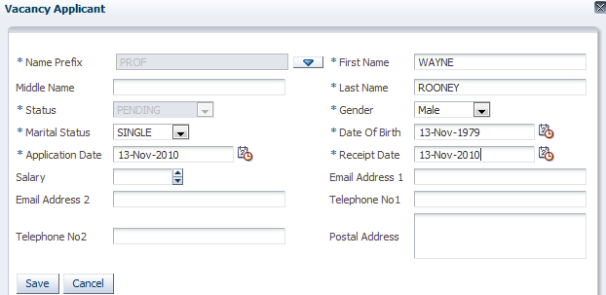

And 

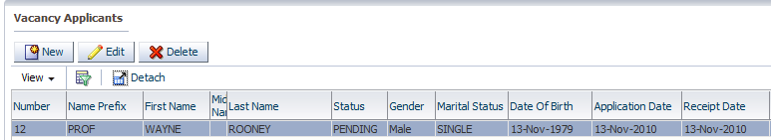

**--** [**Education Background**](http://localhost:7001/HRMS/faces/vacanciesApplctns.jspx?_adf.ctrl-state=5ya0pyanr_139)

Used to capture details of the applicants educational background.

>>

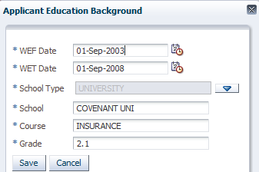

**--** [**Work Background**](http://localhost:7001/HRMS/faces/vacanciesApplctns.jspx?_adf.ctrl-state=5ya0pyanr_139)

Used to capture work background of the applicant

>>>>

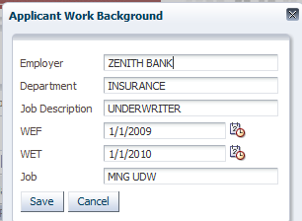>>

**REFREES**

To capture referees of the applicant

Highlight the **applicant**>> click the **tab >>>>**

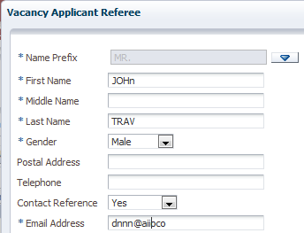

And.

### 2.1.5 APPLICANTS MEDICAL EXAMINATIONS

Used to define the medical examinations for the applicants

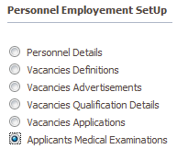>>>>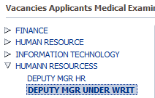

Highlight the personnel,

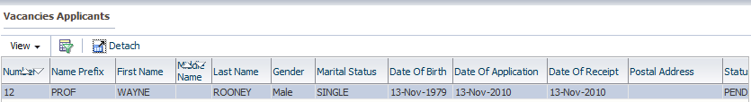

>>>>

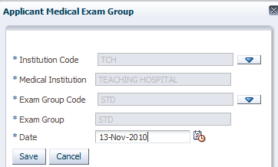>>

>>>>

To create the applicant medical setup click on create button. The system automatically picks previously defined applicants medical examinations.

### 2.1.6 VACANCIES INTIMATION AND INTERVIEW DETAILS

Used to process employment of personnel

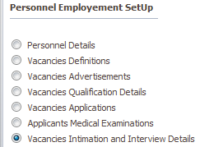>>highlight post>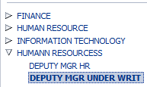

**INTIMATIONS**

Used to capture intimation details

>>>>

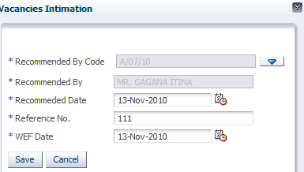>>

**INTIMATED APPLICANTS**: used to capture applicants to be intimated



Highlight the **INTIMATIONS**and

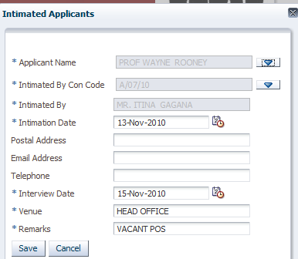>>

**INTERVIEWS:** used to capture the types of interviews conducted and the marks obtained.

>>>>

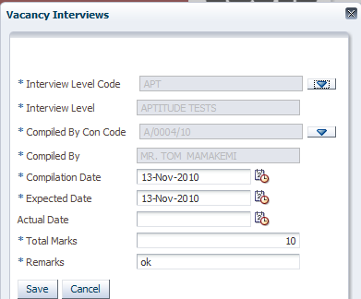

**INTERVIEWED APPLICANTS**

Used to capture details of interviewed applicants



Highlight the INTERVIEWS and select 

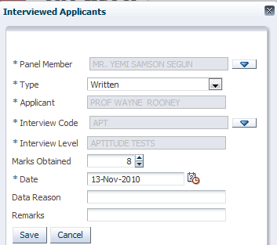

**INTERVIEW DETAILS**

Used to view details of the applicant and interview details

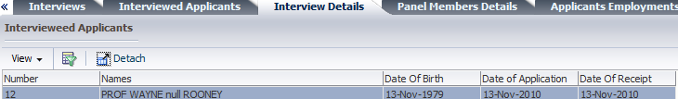

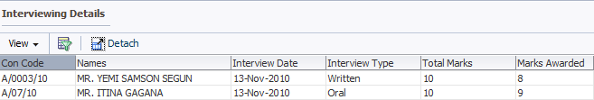

**PANEL MEMBERS DETAILS**

Used to view each panel and details per applicant

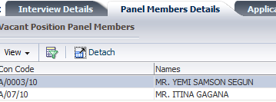

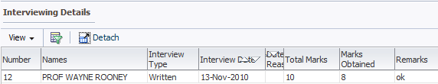

**APPLICANTS EMPLOYMENTS**

Used to employ, amrk applicants as unemployed or unsuccessful

Highlight the applicant

 = used to employ personnel and goes to the next level

 = used to in employ a person but still keeps him/her in database incase he/she can be called back

 = used to knock out a personnel totally out of the system

**APPLICANTS SELECTED FOR EMPLOYMENT**

After clicking  on successful applicant, the screen below is displayed

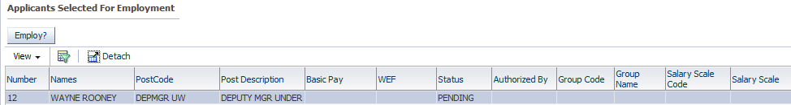

Highlight and >>

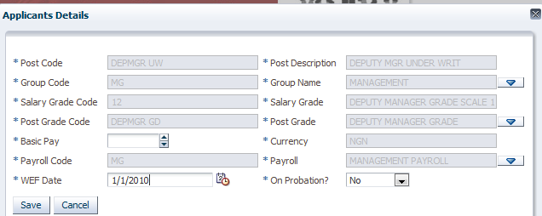

Group name = group to attach personnel so as to assign them the pay elements under that group.

Post grade = post grade to attach personnel

Pay roll = payroll to attach

On probation = if he/she is on probation

### 2.1.7 VACANT POSITION APPLICATION INQUIRIES

Used to inquire on different position application inquires. Select and the details of the applicants will be displayed as shown below

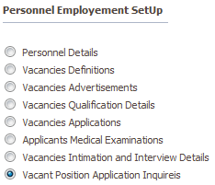>>>>

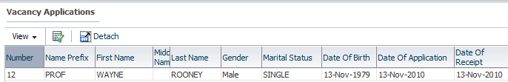

### 2.1.8 VACANCIES PROBATION DETAILS

Used to view probation details of personnel and confirmation details

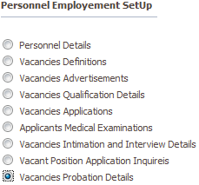>>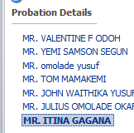>>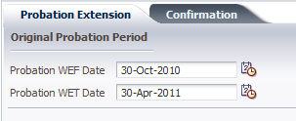

It shows the dates when probation begins and ends. It can also be used to extend probation details>>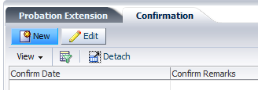

Confirmation details can also be input on the screen for confirmation.

### 2.1.9 PERSONNEL DETAILS

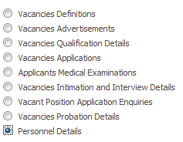>>

After employing personnel, this can be used to view his details and edit his details.

>>>>

Highlight the personnel and key in details as it should be when available

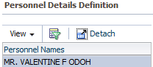 .

NOTE: most of the details can be keyed in the system from the SELF SERVICE and viewed by HR from the HR application

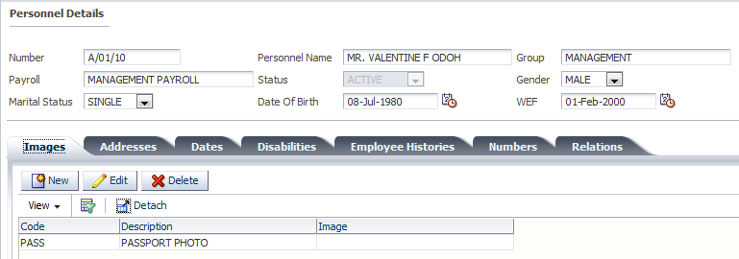

## 2.2 TIME AND ATTENDANCE

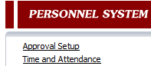

### 2.2.1 WORKING DAYS

To define the working days for the year



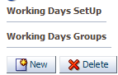

Select  and >>

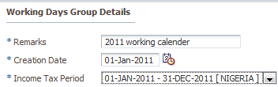

>>

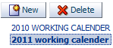And  to generate

### 2.2.2. GROUP REPORTING SETUP

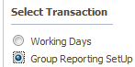

Used to define the working time, days and period for personnel. When a person is employed, he will not have access to the system until they have been assigned a time and period to start work.

>> highlight the group

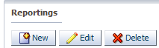

Select to define the reporting start and end of date

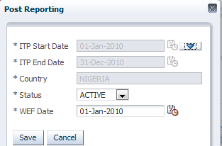



REPORTING DETAILS

Used to define the reporting time and closing time per day



Select >>

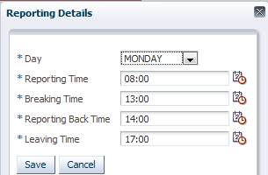>>

REPORTING WORKING DAYS PERIOD

Used to define the first working day of a personnel after employment. The first working day of a

Personnel is defined here.





Pick a date and 

**NOTE**: a person must have been employed and attached to a group before assigning the personnel.

Upon ASSIGNING PERSONNEL for a person that has been employed to a group, the person’s name

Is populated on the SUB MENU PERSONNEL WORKING DAYS GROUP.

PERSONNEL WORKING DAYS GROUP

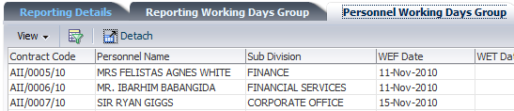

## 2.2.3 PERSONNEL ATTENDANCIES

Used to view previous attendances of personnel and can also be used to manually put time attendances per personnel for situation where they do not have systems and just write sign when they resume.

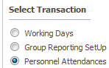**>>**

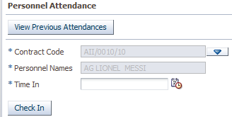

**Contract code** = to pick a person

**Personnel** = populates the personnel after picking the code

**Time in** = if the person has logged in, it populates the last time the person logged in.

But if not logged in or for a person that does not have system, it can used to manually **check in** the personnel.

### 2.2.4 IMPORT PERSONNEL ATTENDANCIES

For situation where personnel won’t have access to the system or attendances will be captured outside the system,

**Personnel recruitment >> time and attendance >> import personnel attendance**

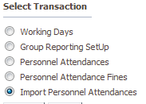

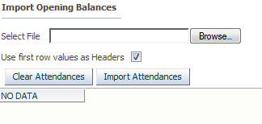

** = to browse for the file to import**

## 2.3LEAVE MANAGEMENT

Used to define the various leave, setups and processing leave allowance

**Personnel system >> leave management**

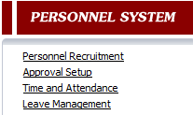

### 2.3.1 LEAVE TYPES

Used to define the various **leave types** within an organization.

Personnel system >> leave management >> leave types

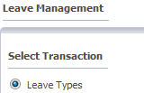>>

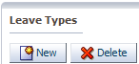

Select  and fill up

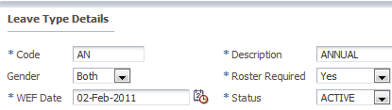

Description = name of the leave

Gender= which gender has the right to go for this leave

Roaster required= if a roaster is needed for this leave

And 

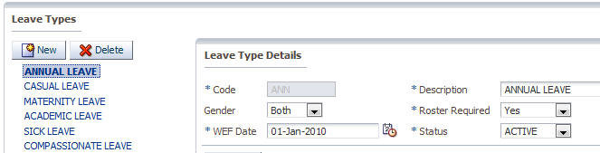

**FORFEITED PAY ELEMENT**

Used to define pay elements that will be forfeited when this leave is taking if it is applicable to that leave



Select 

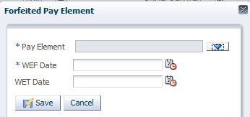

Pay element = the pay element that should be forfeited

WEF = with effect from i.e. date it should start

**GROUP**

Used to attach the leave types to groups: highlight the leave type

>>

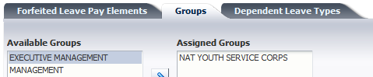

Highlight the **group** and  to move

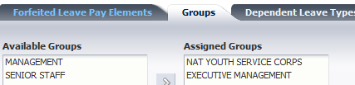

**DEPENDENT LEAVE TYPES**

Some leaves depend on others, this can be defined here.

Highlight the leave





Select >>

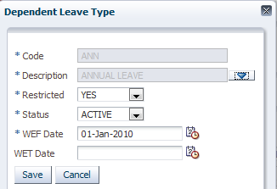

Description = pick the leave it will depend on

Restricted = if **yes**, means if this **leave** is taking, it is deducted from the **leave** it depends on.

And 

### 2.3.2 PERSONNEL LEAVE TYPES

Used to attach the different **leave types** to personnel

Personnel system >> leave management >> personnel leave types

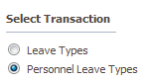>>

 = highlight the personnel

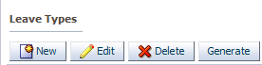

Select  to add one by one

Or  to populate all **leave types** that have been pre-defined

### 2.3.3 LEAVE PERIODS

Used to setup the necessary parameters for each of the **leave types** that have been defined

**Personnel system >> leave management >> leave periods**

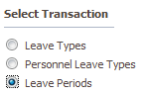>>

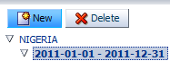 = highlight the **period**

And select 

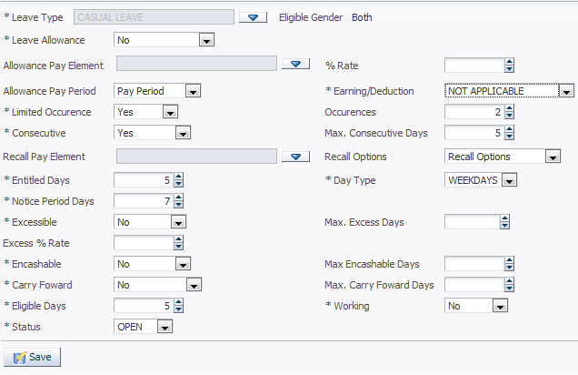

Upon saving 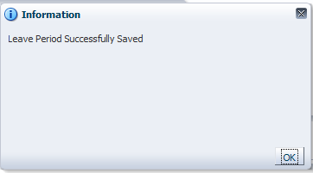

**Leave type** = the **leave type** to define the setup

**Leave allowance** = **processing of leave allowance** if this leave is taking

**Allowance pay element =** the allowance pay element to be paid

**Rate=** the percentage rate of annual salary to be paid on the **leave allowance**

**Allowance pay period =** this is associated with personnel’s that go on leave within a year, whether their **leave allowance** should be paid on **anniversary (1 year after recruitment)** or **end of the year**

**Max consecutive days =** the maximum number of consecutive days that can be taking by a personnel on this leave

**Earning/deduction =** if the allowance to be paid is an**earning** or **deduction**

**Entitled days** = the number of days a personnel is entitled to

**Day type=** days that are included in the leave. **Weekdays, weekends or both**

**Notice day periods=** the maximum number notice day periods before taking this **leave**

**Encashable** = if this leave is **Encashable**

**Carry forward** = if this **leave** can be carried forward to the following year

**Excessible =** if there is excess, like extra days that can be giving on that **leave**

**PERIODS PER POST LEVEL**

After defining the setup for a particular LEAVE, it is possible that some personnel’s in a certain **post level** can have a different **setup**to a particular leave. And this can be done on this **tab.**

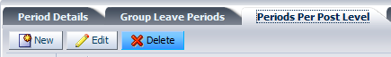

Select >>

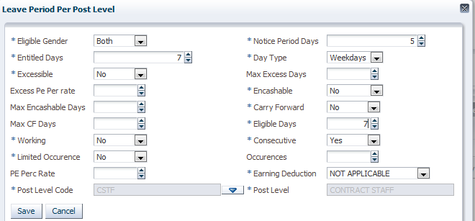

**NOTE:** post level code is been attached. And.

Now to generate the **leave period** for all personnel.

Highlight the **leave** and

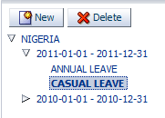>>

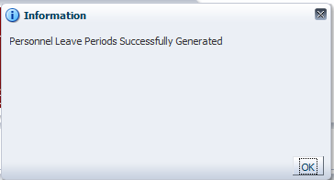

To view the different **leave periods** per **personnel**.

On the **personnel leave periods**

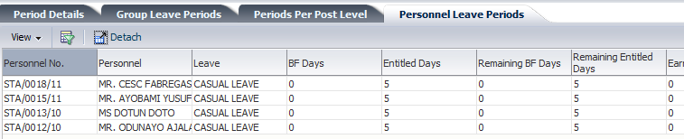

### 2.3.4 LEAVE ROASTER

Used to keep a roaster of **personnel** and period each staff intends to go on **leave** at the beginning of the year

**Personnel system >> leave management >>leave roaster**

The transactions are initiated from the **HRMS_SS (self service)**and it is approved on the HR application.

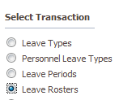 . Highlight the **leave type**

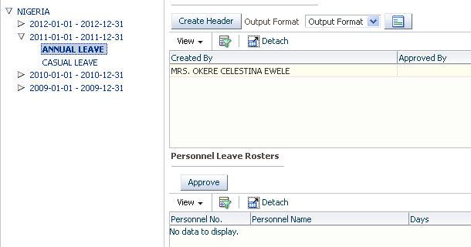

### 2.3.5 LEAVE ENQUIRY

**Personnel system >> leave management >>leave enquiry**

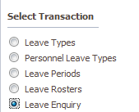

It is a view screen to view all employees and **leave** they have each taking and view the necessary details.

Highlight the **personnel**

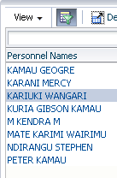 >>

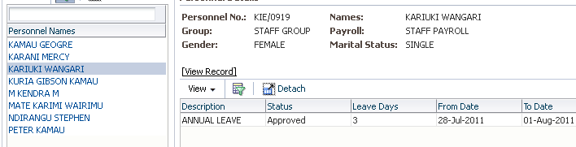

### 2.3.6 MANUAL LEAVE PROCESSING

**Personnel system >> leave management >>leave allowance processing**

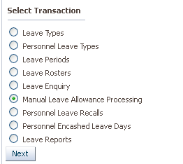

Used to process the leave allowance for personnel’s who have not gone on leave.

Highlight leave type and select name of employee to process and process

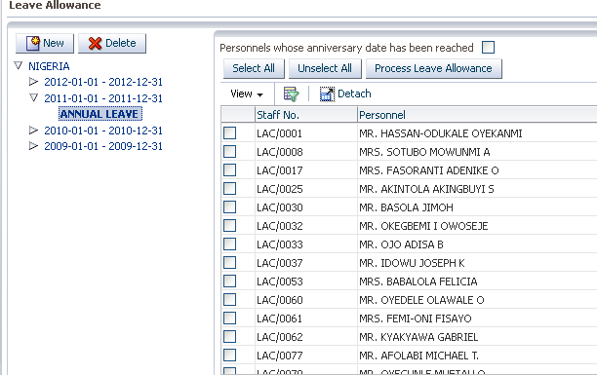

### 2.3.7 PERSONNEL LEAVE RECALLS

**Personnel system >> leave management >> personnel leave recalls**

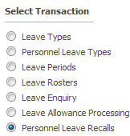>>

Used to process **leave recall** of a personnel.

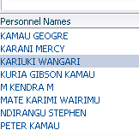 >>



Pick the recall date

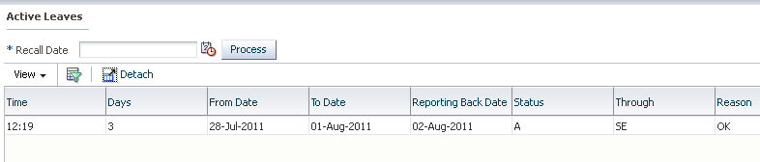

Tick the **check box** and.

## 2.4 STAFF WELFARE

**Personnel system >> staff welfare**

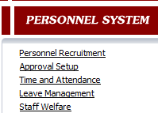

### 2.4.1 STAFF RECREATION POLICY

**Personnel system >> staff welfare >> staff recreation policy**

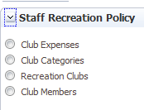

Used to the different recreational policies and expenses for personnel

--**CLUB EXPENSES**

Used to define the different expenses that can be incurred.

>>



Select  and wait for the window

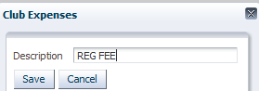.

**--CLUB CATEGORIES**

Used to define the different club categories

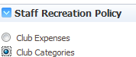>>

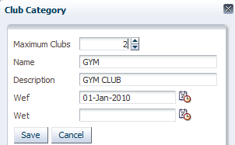

Maximum clubs = maximum number of clubs that can be defined under this category

Name = name of the club

WEF = when this was created In the system

And 

**--RECREATION CLUBS**

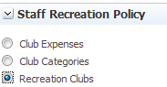>>

Used to define the various clubs and their various expenses

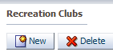

Select  and

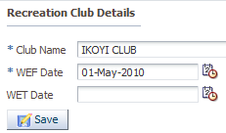>>

Club name = the name of the club

**TO CAPTURE THE RECREATIONAL EXPENSES**

Highlight the **recreational club**

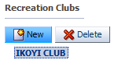**>>**

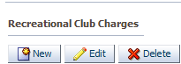**>> select >>**

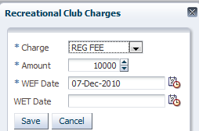

**Charge =**the different expenses that were predefined.

**Amount=** the amount for that **charge** per **recreational club**

And 

**--CLUB MEMBERS**

Used to capture the different personnel per **clubs** per **expenses/charge**

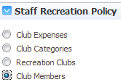**>>>>**

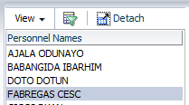Highlight the personnel**>>**

TO CAPTURE THE RECREATIONAL CLUB

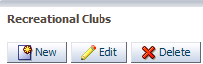>>>>

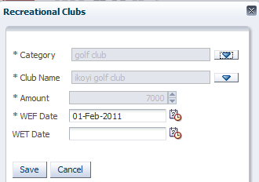

**Category** = the category of the club the employee belongs to

**Club name** = the name of the club

**And **

TO CAPTURE THE RECREATIONAL TRANSACTION PER CLUB

Highlight the **recreational club** and

>>>>

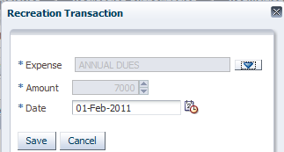

Expense = the expense for that club

Amount = the amount for that expense

And 

**MEMBERSHIP OF EMPLOYEE**

This can serve as a view screen to see which personnel attached to a club or it can be used to attach personnel to **recreational** club and their **expenses**

Highlight the club

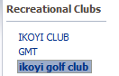>>

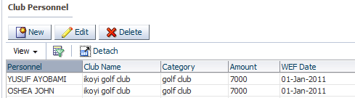

TO CAPTURE THE DETAILS FROM THIS SCREEN,

Select >>

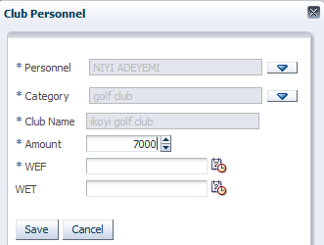

And 

RECREATION AUTHORIZATION

This is used **authorize** the recreation.



Highlight the **personnel**

 = to submit for approvals

 = to approve before a **cheque requisition** can be created

REQUISITION

Used to create requisition for the **authorized recreation**



Highlight the personnel >>

 = to create the requisition

### 2.4.2 MEDICAL SCHEME

Personnel system >> staff welfare >> medical scheme

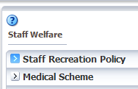

--**MEDICAL BENEFITS**

Used to define the various medical benefits

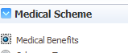>>>>

>> select >>

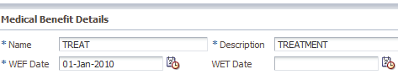

And 

After defining the **medical benefits,** we define the **section** under each benefit

Highlight the **medical benefits,**

>>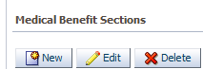>> select >>

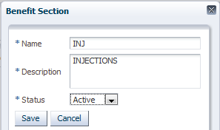

Name = name of the section

Description = short description

Status = to make it ready and available.

And.

**--SCHEME TYPES**

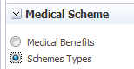>>

>>>> it clears the right hand side for details to be passed on

>>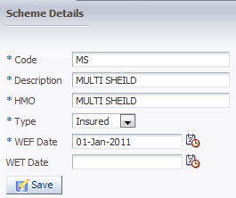

Code = short code

Description = full description of the **scheme**

HMO = name of the HMO

Type = insured/self fund

And.

**PREMIUMS**

Highlight the **medical scheme types**

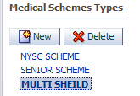**>>**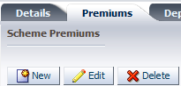

Click **premiums** and select  and wait for window

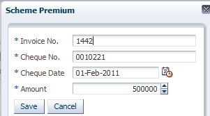

Invoice no = the invoice number

Cheque no = no on the **cheque** that was giving to the HMO

Cheque date = the **cheque** date

Amount = amount that was given to that HMO

And.

**DEPENDENCY TYPE**

Used to define the dependency type

Highlight the **scheme**

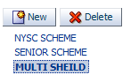

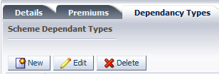**Select**

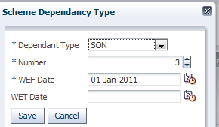

Dependent type = dependent type

Number = number of dependent types

WEF = with effect from

And 

**CATEGORIES**

Used to define the categories under a scheme

Highlight the **scheme type**

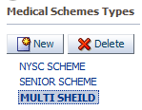**>>**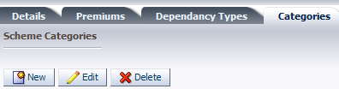

Select >>

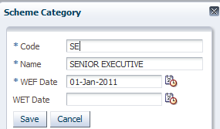

Code = short code

Description=description

WEF = with effect from

And 

**SCHEME MEDICAL INSTITUTION**

Used to define all the scheme medical institution

On the tab **scheme medical institutions**

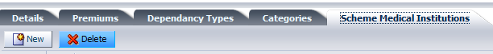

Select >>

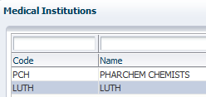>> pick the institution >>

**--SCHEME CATEGORY TYPES**

Personnel system >> staff welfare >> medical scheme >> scheme category benefits

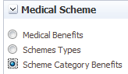>>>>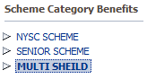>>

Drop down the arrow of the **scheme** and highlight the **category**

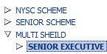>> On the right hand side >>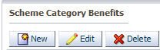>>

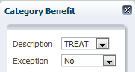

Description = the description

Exception = whether there is an exception.

And.

After saving, on the left hand side, highlight the **category** and **drop down** the **arrow**

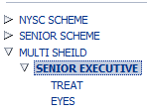>>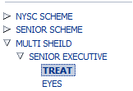>> on the right hand side

Select  and

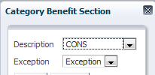

Description = the description of the benefit

Exception = if it is an exception.

And .

--**SCHEME CATEGORY PERSONNEL**

Personnel system >> staff welfare >> medical scheme >> scheme category personnel

Used to define **personnel** per **scheme**

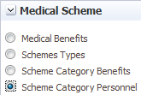**>>>>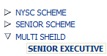>>**drop down the arrow and pick the category

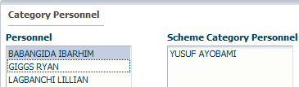

highlight the personnel >> =to move the personnel

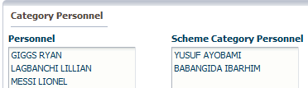

After moving

**--SCHEME CLAIMS**

Used to capture claims by personnel

Highlight the category

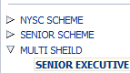>> pick personnel >>>.

On the right hand side: **category personnel claims.** Select >>

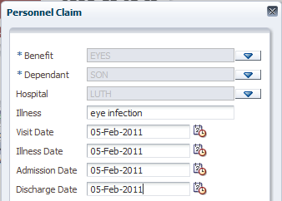

Benefit = the benefit the claim belongs to. Picked from a **LOV**

Dependent = the dependent. Picked from **LOV**

Hospital = the hospital visited. Picked from **LOV**

Illness = name of illness

Visit date = visit date

Illness date = date of illness

Admission date = admission into the hospital

Discharge date = date of discharge

And 

After saving, below is the **claim section**

**NOTE:** highlight the **category personnel claim**

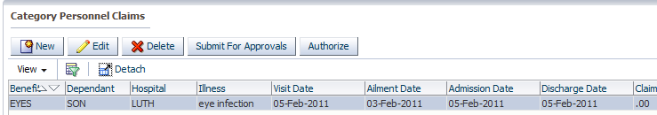

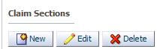>> select >>

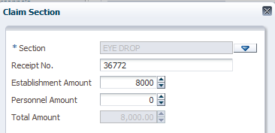

Section = the section of the claim

Receipt no = the number on the receipt

Establishment amount = the amount the organization will pay for the claim

Personnel amount = the amount the personnel will pay

And .

### 2.4.3 SERVICE AWARDS

Core setup >> staff welfare >> service awards

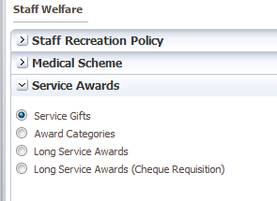

**--SERVICE GIFTS**

>>>>

Highlight the group

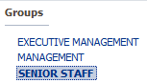>> On the right hand side >>>>

Select >>

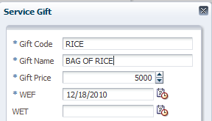

Gift code = code of gift

Gift name = name of the gift

Gift price = the price of that gift and save

WEF Date=With Effect from Date

WET date= With Effect To Date

**--AWARD CATEGORIES**

To setup awards per category

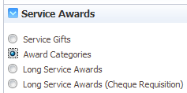>>>>

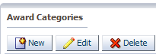>> select >>

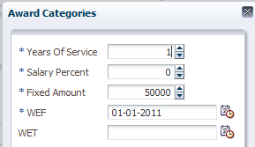

Years of service = years worked in the organization

Salary percent = percent of salary

Fixed amount = a fixed amount

And 

.

**--long service awards**

Used to process long service awards

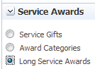>>>>

 Pick the date

 = to generate personnel



 Tick the check box of personnel to process

**--long service awards (cheque requisition)**

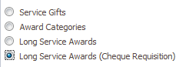**>>>>**



Tick the personnel to create a requisition to go to the **Finance Management System**

** =** to create the requisition

### 2.4.4 STAFF BUS

Used to setup the bus transactions, charges and routes

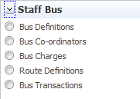

**--BUS DEFINITIONS**

This is used to capture bus definitions

**>>>>**

**>>>>**

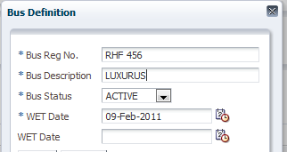**>>>>**



**--BUS CO-ORDINATORS**

To define bus co-coordinators

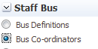>>>>

>> select >>

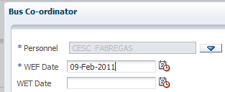>>

**--BUS CHARGES**

Used to define bus charges

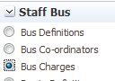>>>>

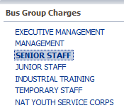 Highlight the group >>>>

Select >>

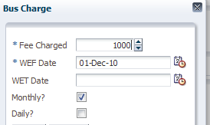

Fee charge = the fee charge

Monthly = if it is a monthly payment

Daily = if it is a daily payment

And 

**--ROUTE DEFINITIONS**

To define the route definitions

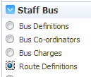>>>>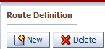

Select >> on the right hand side >>>>

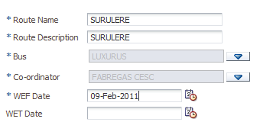 And  .

--To attach personnel to this route

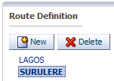 Highlight the route >>>>

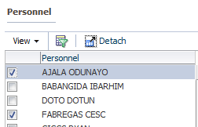Tick personnel to move >>>>

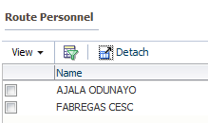

--**BUS TRANSACTIONS**

To process the bus transaction

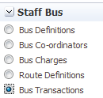>>>>

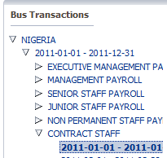 Drop down arrow to pick the payroll and highlight the period

### 2.4.5 FINANCIAL ASSISTANCE

Used to capture, setup and process financial assistance

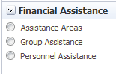

**--assistance areas**

Used to define the assistance areas

**>>>>**

**>> select >>**

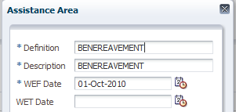**>>.**

**--group assistance**

Used to define the assistance per group

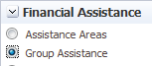**>>>>**

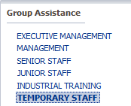Highlight the group>>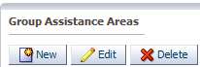>>>>

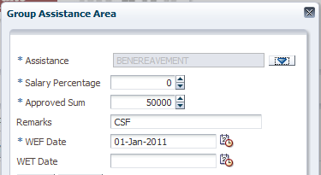

Assistance = the assistance area

Salary percentage = if it is a percentage of salary

Approved sum = the approved sum

And.

**--personnel assistance**

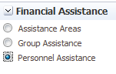**>>>>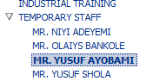**drop arrow and highlight the personnel

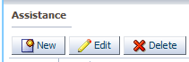>> select >>

## 2.5 PERFORMANCE MANAGEMENT

Home>Personnel System> Performance Management

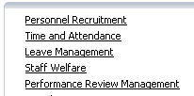

### 2.5.1 Appraisal Groups

Used to create and assign employees to groups that will be used during the appraisal process.

Select the appraisal group on menu and click on next to display the screen below

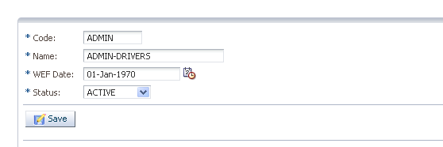

Click on new and give the following details;

Code= short description of appraisal group

Name= full name of appraisal group

WEF date= with effect from date

Status= select to show if the group is Active or Inactive

Expand the appraisal group select the group, select the name of the unassigned employee and assign them to the group created.

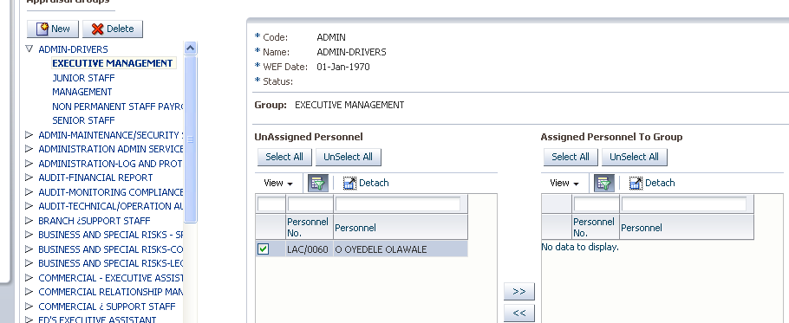

### 2.5.2 Appraisal setups

**Appraisal types**

Used for defining the different types of appraisal to be used during the appraisal process

Click on appraisal types tab the screen below will be displayed

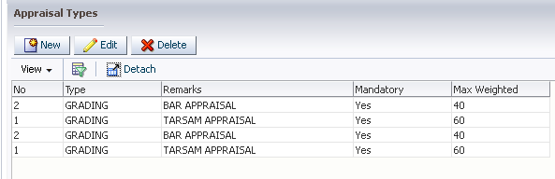

Click on  new record to get the screen below

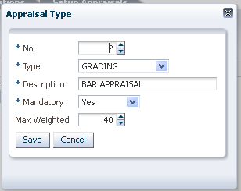

NO= appraisal type number

Type= select the appraisal type from the LOV.

Description= Short description of appraisal type

Mandatory= Select from the list of values if the type is mandatory

Max Weighted= give the maximum weighted value of the appraisal type and click on >>

**Performance Indicators**

Used for defining indicators to be used in measuring performance.

Click on Performance indicators tab the screen below is displayed

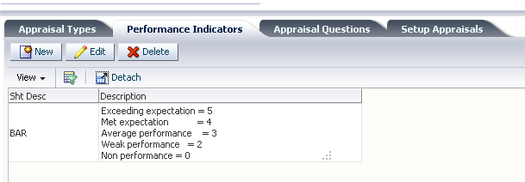

Click on new record >>> to give the screen below

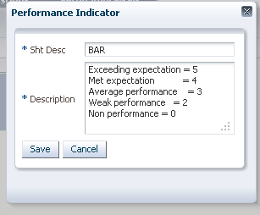

Sht Desc=Give the short description of the indicator.

Description= give the description of the indicators and click on save.

**Appraisal Questions**

Used for setting up appraisal questions to be used during the appraisal process

Click on Appraisal Questions tab to display the screen below

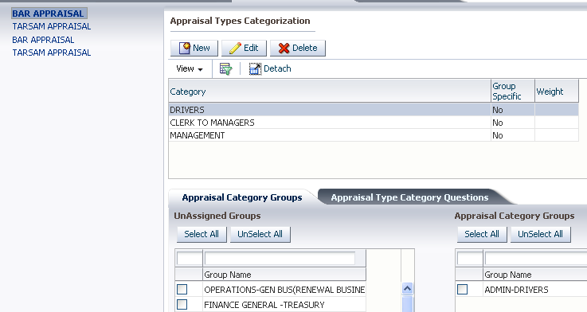

Select appraisal type and on Appraisal Type Categorization and click on >>

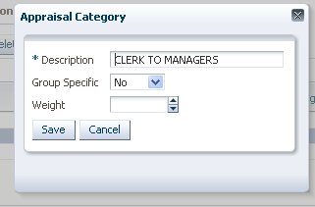

Give the details below

Description =Give full description of category

Group Specific= select if the category is group specific

Weight= Give the weight to be used in the category you have defined and click on save.

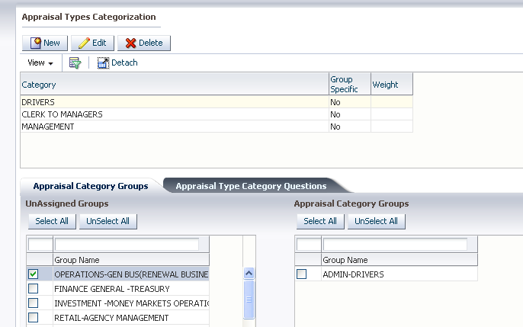

Select the category defined and assign to it any category groups that are applicable to the defined category as shown above.

Click on the Appraisal Type Category tab to display the screen below

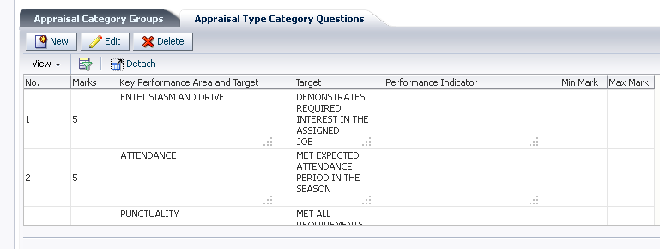

Click on  the screen below will be displayed

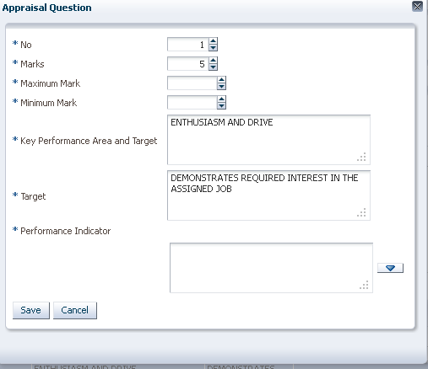

No=numerical number of the question

Marks= total mark you expect from the question you are setting up

Maximum Mark=Give the maximum mark you expect from the set up question.

Minimum=Give the minimum mark you expect from the question you are setting up.

Key performance area and target=describe the key performance are or target area

Target= Set up the target that you expect to be met.

Performance = Set up the indicators.

Click on save to save the record

**Setup Appraisals**

Click on setup appraisal to display the screen below

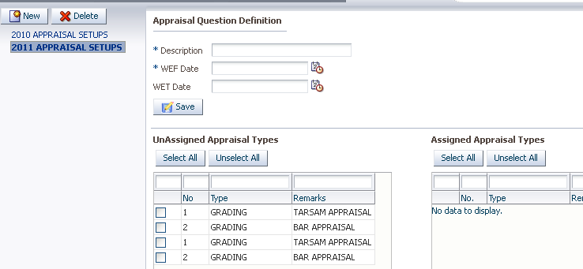

Click on  to display the screen below for defining appraisal question definition

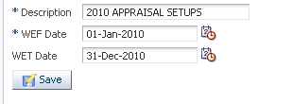

Give the Description, With Effect from Date and With Effect To date and save record.

### 2.5.3 Performance Review Periods

Used to define performance review periods

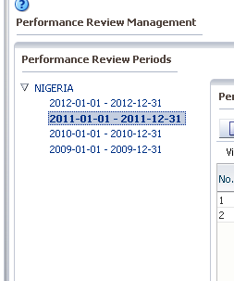

Highlight the country and year you are creating performance periods for the screen below will be displayed

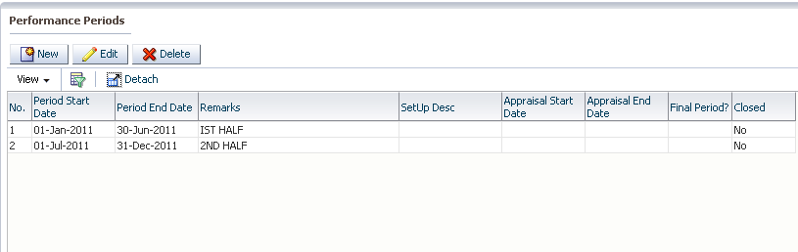

Click on  the >>>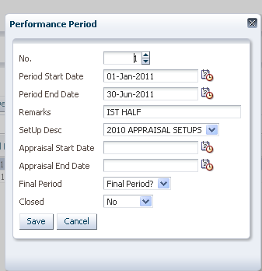

Give the following details

**No=**numerical value of the period

**Period start date=** the period start date for the performance review period

**Period end date=**the end date for the performance review period

**Remarks=** Any remarks on the period defined

**Setup Desc=** select the short description

**Appraisal start date=** give the appraisal start date

**Appraisal end date=**Give the appraisal end date

**Final period=** select if the period if final

**Closed=** select if the period is closed.

**Global performance rating**

Used to define performance ratings

Personnel Management>> performance Management> Global performance rating

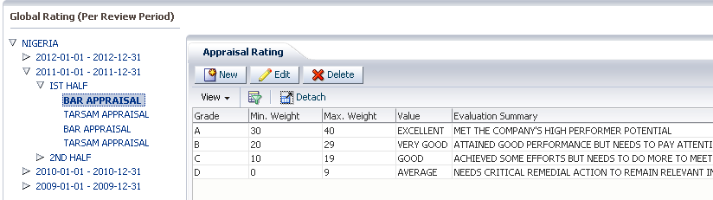

Highlight the appraisal type and click on  to display the screen below

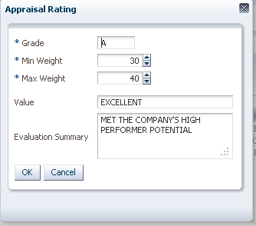

Give the following details

**Grade**= Give the grade

**Min Weight**= the minimum weight

**Max weight=** Give the maximum weight

**Value= give the value**

**Evaluation summary=** give any evaluation summary for the rating set.

### 2.5.4 Final performance rating

Used to process and view final score results and set up final grade setups.

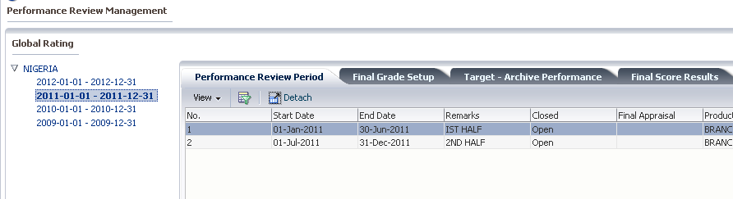

**Performance review period**

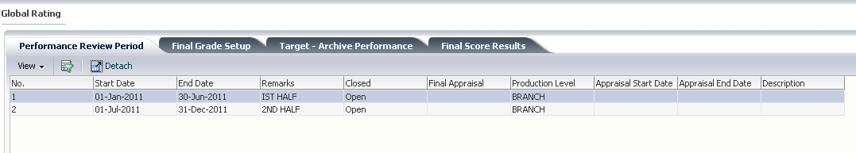

**Used to view the performance review periods previously defined.**

**2.5.5 Final grade setup**

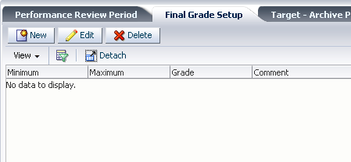

Used for setting up final grades. Click on  to display the screen below

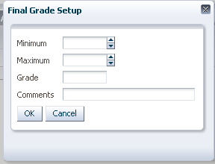

**Minimum**= give the minimum mark for grade

**Maximum**= Give the maximum mark for grade

**Grade**= give the grade

**Comments**= give the comments

**Target achieve performance**

Used to import targets schedule and process the targets.

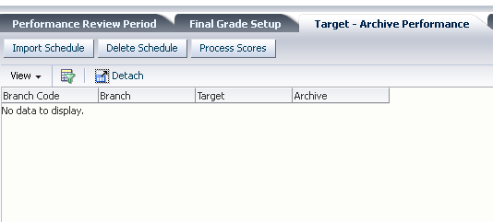

### 2.5.6 Appraisal recommendations

**Any personnel recommendations can be captured from this screen. The recommendations maybe due to the appraisal of the**

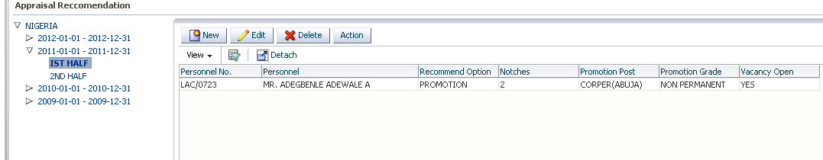

Click on  to display **>>>>>**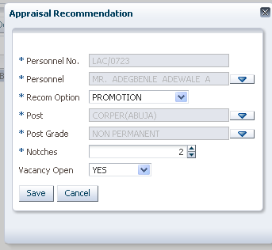

Give the following details

**Personnel no**= From the LOV should be able to select the personnel and their no.

**Personnel**= Displays the personnel name picked for the list of personnel

**Recom option**= select the recommendation option for the employee it can be either promotion or salary increment

**Post**= select the post the individual is being promoted to.

**Post grade**= select the post grade the individual is being promoted to.

**Notches**= input the number of notches the promotion

**Vacancy open**= select if the vacancy is open or closed click on save

Highlight the record and click on 

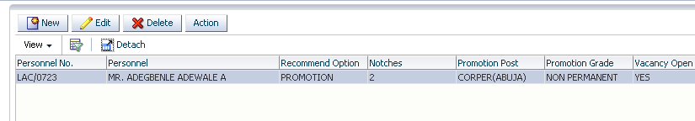

## 2.6 DISCIPLINARY MANAGEMENT

Used to setup, process and view disciplinary actions and appeals

Home >> personnel system >> disciplinary management

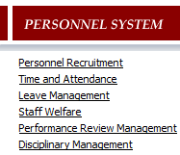

### 2.6.1 ESTABLISHMMENT POLICIES

This is to define the establishment policies

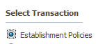>>>>

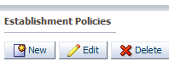>> select >>

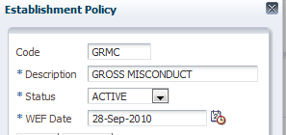>>

### 2.6.2 DISCIPLINARY ACTION SETUP

Used to define the different actions

>>>>

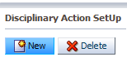>>

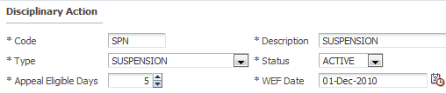

Code = short description of the action

Description = description of the action

Type = the type

Appeal eligible days = maximum number of days a personnel can appeal

And.

**--action pay elements**

Define the pay elements that will be affected if this action was to be taking

Highlight the **action** just defined

>>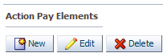>>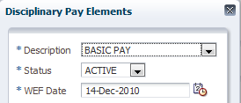>>.

### 2.6.3 POLICY DISCIPLINARY ACTIONS

This is used to attach the policies to the actions defined

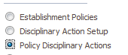>>>>

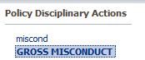 Highlight the action defined >>on the right hand side

Select >>

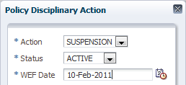>>

### 2.6.4 PERSONNEL DISCIPLINARIES

Used to view personnel that have been disciplined and the progress.

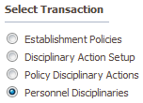>>

 Highlight the personnel to view if disciplined >>on the right

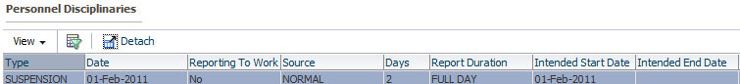

**NOTE:** to discipline a personnel is always initiated from the **self service** and can be viewed on this screen.

Highlight and >>

to change the personnel position >>>>

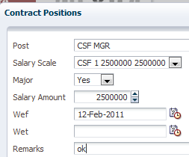

Post = the new post personnel is been moved to

Salary scale = the new salary scale

Major = if it is a major movement

Salary amount = the salary he/she is expected to collect

And.

## 2.7 PERSONNEL MOVEMENT

This is used to capture personnel movement from increment in salary to change of post

Home >> personnel system >> personnel movement

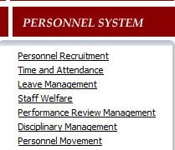

### 2.7.1 MOVEMENT PARAMETERS

>>>>

Highlight the group

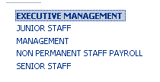>>>>

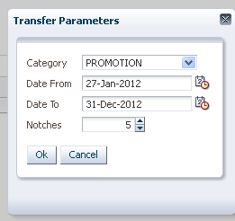

Category = Select the movement category

Date from = date from which the notch is applicable

Date to = date to which the notch is applicable

Notches= number of notches personnel is to move during promotion.

And 

### 2.7.2 PERSONNEL MOVEMENT ELEMENT

To define pay elements that will be given to personnel for movement e.g. relocation allowance



>>> 

Highlight the post

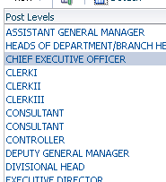>>>>

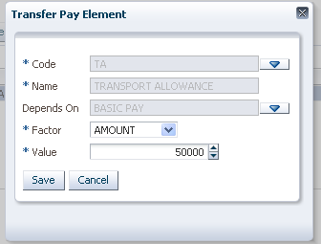

**Code**= short description of pay element.

**Name**= Name of pay element

**Depends on**= attached pay element that is depended upon by the transfer pay element.

**Factor**= the factor that determines the pay element.

**Value**= actual value of the pay element.

**--transfer branch**

Highlight the pay element

>>

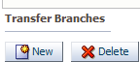>>>>

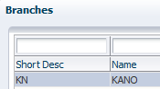>>.

### 2.7.3 PERSONNEL MOVEMENT

This is used to setup and process personnel movement

>>>>



Highlight the personnel >> on the right hand side >>

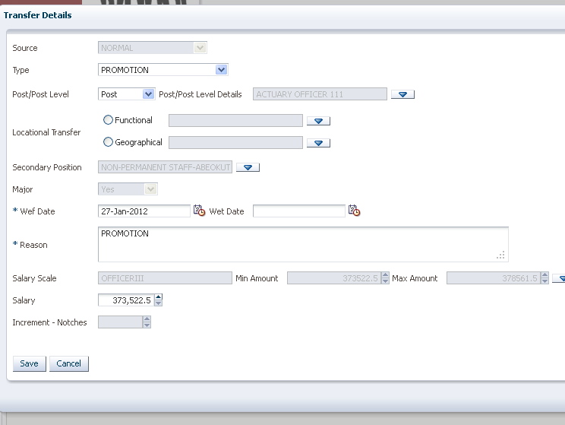

**Type** = list the different types of transfer

* promotion = movement from a post to a higher post
* demotion = movement from a post to a lower post
* salary increment = increase in salary
* salary decrement = decrease in salary
* secondary responsibility = extra functions
* promotion/salary increment = promotion and increment in salary
* demotion/salary decrement = demotion and salary decrement

**Source** = this is the source of the transfer

**Location Transfer** = can be functional or geographical

**Secondary position** = If Personnel is being assigned a secondary position

**Major**= if it is increase in salary, that is a major movement

**WEF Date**=the date from which the movement is effective

**WET Date**= End date of movement changes

**Reason**=any reasons leading to the change

**Salary Scale**= select the new salary scale.

**NOTE: the type picked is what drives the other functionalities to appear**



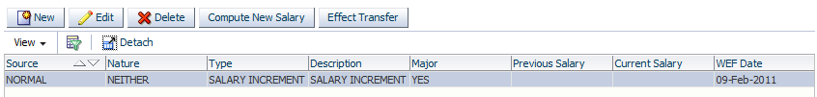

 = to compute new salary if it is any form of increase in salary

 = if it is a transfer to a location or post

## 2.8 SUCCESSION PLANNING

This is used in setting up, searching and processing personnel for a top management vacant post

Home >> personnel system >> succession planning

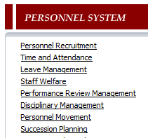

### 2.8.1 SUCCESSION SETUP

Used to setup the post that is available

>>>>

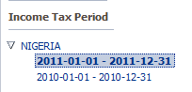 Drop the arrow and pick the year

**Succession post =** to define the post

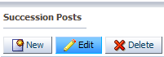>>>>

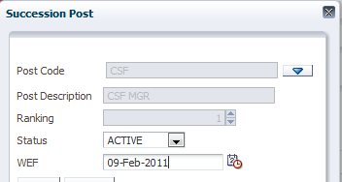

Post code = to pick the post

Status = if active

And 

**Successor sub divisions**

To define the successor subdivision, highlight the succession post



>>>>

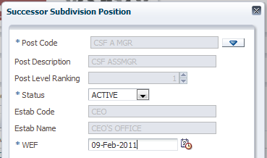>>

### 2.8.2 SUCCESSION PERSONNEL SETUP

Used to setup the successor to the post

>>>>

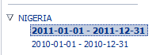 Drop down arrow and pick the year >>

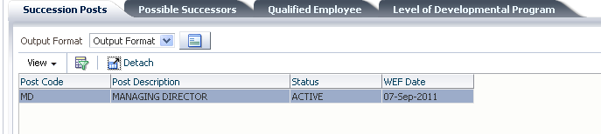

Highlight the **succession post >>**click the next tab

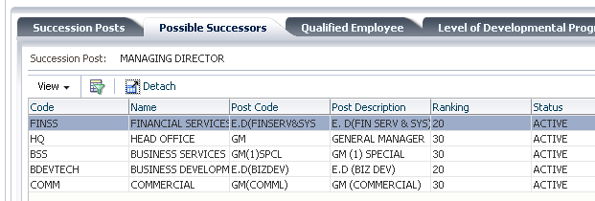

Highlight possible successor subdivision and go to the next tab

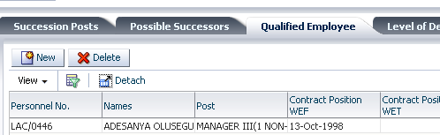>>>>

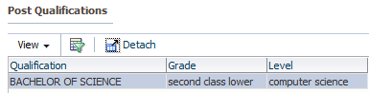 = this is the qualification held by the succession post, highlight and >>

>> = To find qualifying personnel

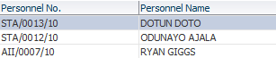 This populates a list of personnel in the system that have the required qualification and above.

This search can also be narrowed down to >>

 = putting the minimum and maximum age limit

And  to research >>

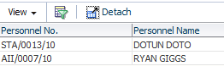 The list has been reduced to one

>>to save

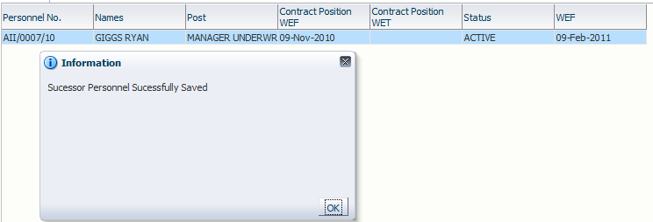

The personnel has been picked

After getting the personnel, he/she can be recommended for training

**--qualification training recommendation**

Select the tab >>

>>>>

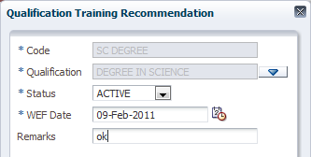>>

Qualification = pick qualification from LOV



**--level training recommendation**

After defining the qualification, this tab is used to pick the level to be trained for

>>

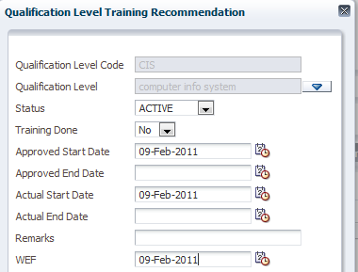>>

## 2.9 LEARNING AND DEVELOPMENT

Go to personnel system>>learning and development

The screen below will be displayed

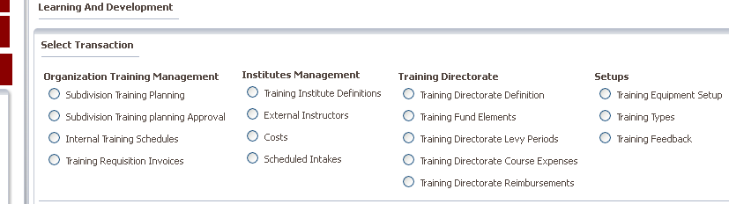

### 2.9.1 Setups

**Training equipment setup**

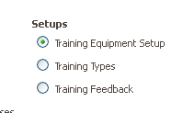**>>>>**

Click in new to display the screen below

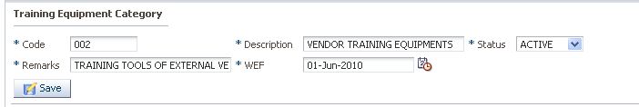

Code= short description of equipment category

Description= full description of training category equipment

Status= select status from the LOV

Remarks= Give any remarks regarding the category defined.

WEF date= give the with Effect date from.

Select the category defined to define training equipments under it

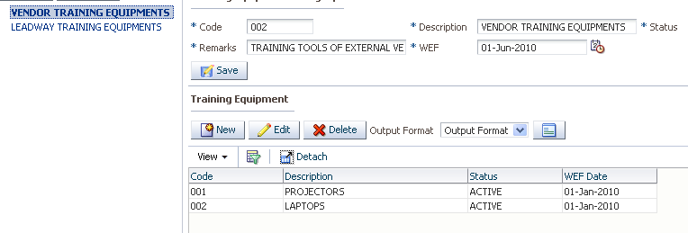

From the training equipment click on new to display the screen below

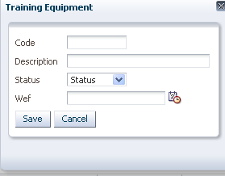

Code= short description of training equipment

Description= full description of the equipment

Status= current status of the equipment

Wef= with effect from date and click on save

**Training types**

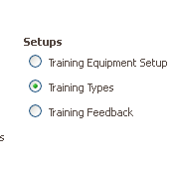**>>>>**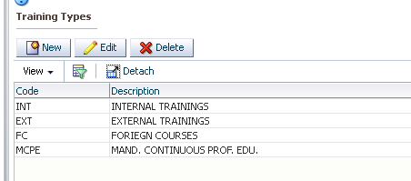

Click on new record >>>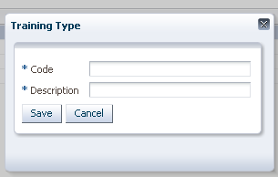

Code= short description of training type

Description=full description of training type and click on save

**Training Feedback**

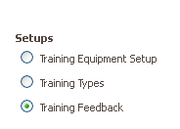**>>>>>**

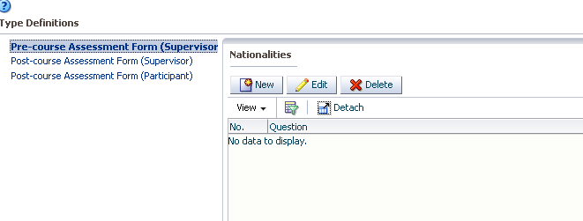

Select the assessment form and click on new the screen below will be displayed

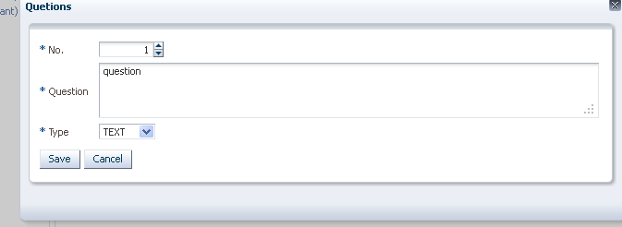

No= numerical value of question

Question= question to be used to assess

Type= select type form LOV as either range or text

### 2.9.2 Organizational training management

Used to define and process organizational training needs.

**Subdivision training planning**

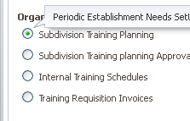>>>> screen below is displayed

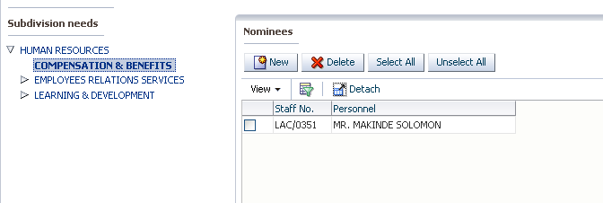

Select the income tax period and select subdivision and click on new the screen below will be displayed

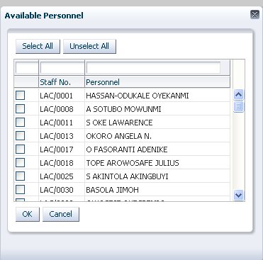

Select name of personnel and click ok to display screen below

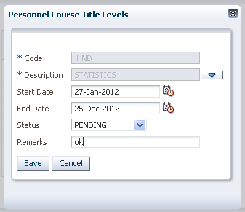

Code= short description of course level titles

Description= full description of course level title

Start date= course start date

End date= course end date

Status= select status from LOV

Give remarks and click on save button

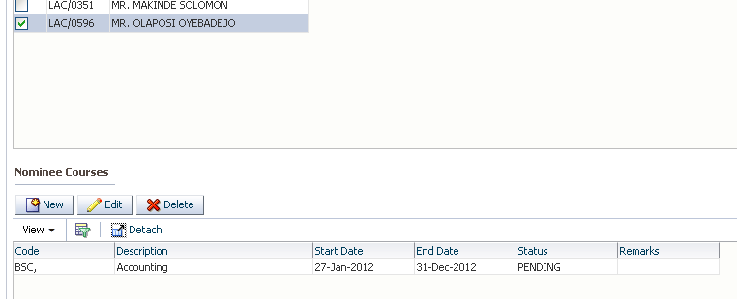Select the personnel nominated go to nominees courses and click on new to display the screen below

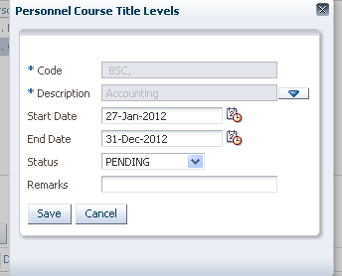

Code= short description of nominated course

Description=full description of nominated course

Start date= expected start date of course

End date= expected end date of course

Status= current status of nominated course

Remarks= any remarks on the nominated course. And click on save.

**Subdivision Training planning approval**

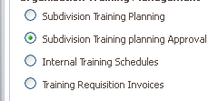**>>>>**

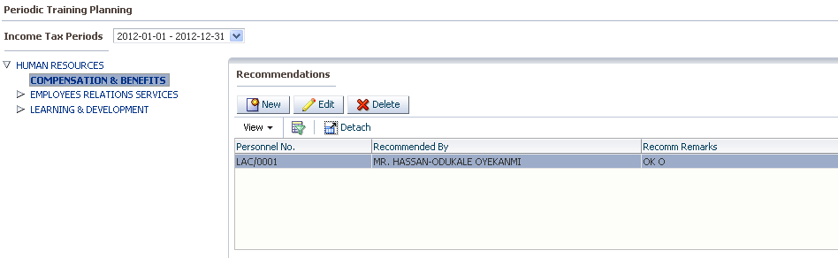

**Select the period, select the subdivision and click on new to display the screen below**

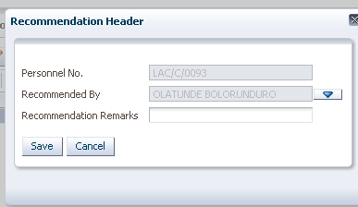

Personnel number= number of recommendation header

Recommended by =name of the person recommending

Recommendation remarks= any remarks leading to the recommendation.

Select recommendation header go to 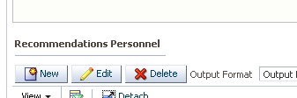 and click on new to display the screen below

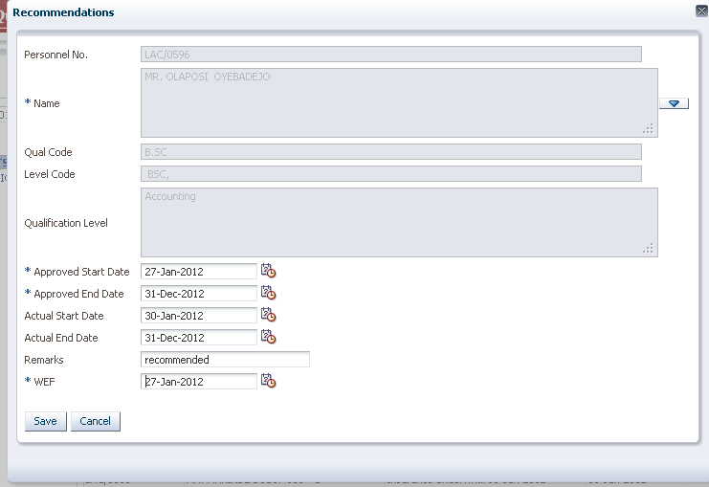

Select the name of the recommended personnel this should pick from the previous screen where the personnel was nominated

Give the approved start and end date, actual start and end date remarks and with effect from date and click on save.

**Internal Training schedules**

Used to generate internal training schedules

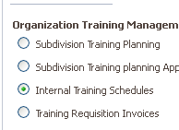>>>>>

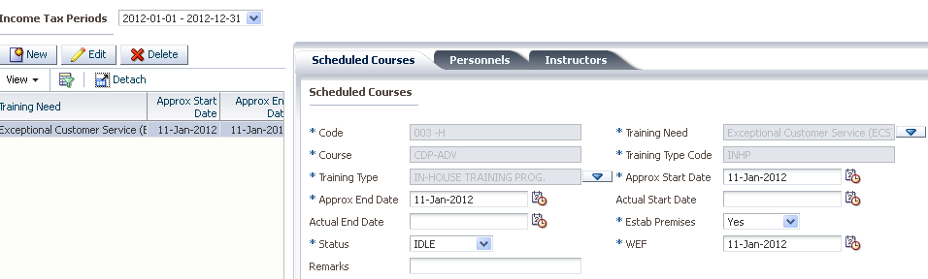

**Scheduled courses**

Select the period, training need and go to tab for scheduled courses

Code= short description of course

Course= full description of course

Training need= select the training need from list of values

Training Type= select the type of training

Approximate start date=Give the approximate date that you expect the training to start

Estab premised= select if training is to be conducted at the establishment premises

Wef = the with effect date from

Status= status of scheduled course.

**Personnels**

Go to personnel tab and click on new to display the screen below

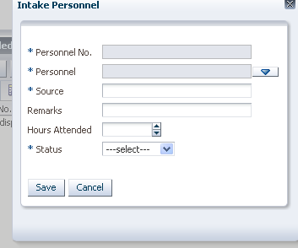

Select the personnel name

Give the source

Give any remarks

Hours attended and the status and click on save.

**Instructors**

Go to instructors tab and click on new record

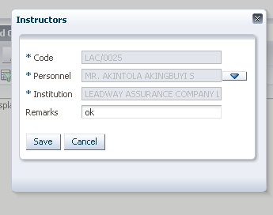

Code= short description of instructor

Personnel = full name of personnel

Institution= institution to which personnel belongs to

Select instructor saved and go to 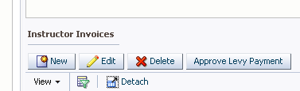 and click on new to display screen below

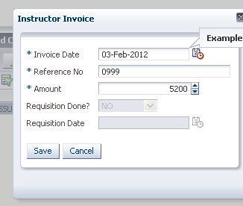

Invoice date= give the invoice date

Reference no= any reference no referring to the instructor

Amount= give the amount

Click on save and click on  to approve the invoiced amount

**Training requisition invoices**

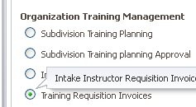**>>>>> **

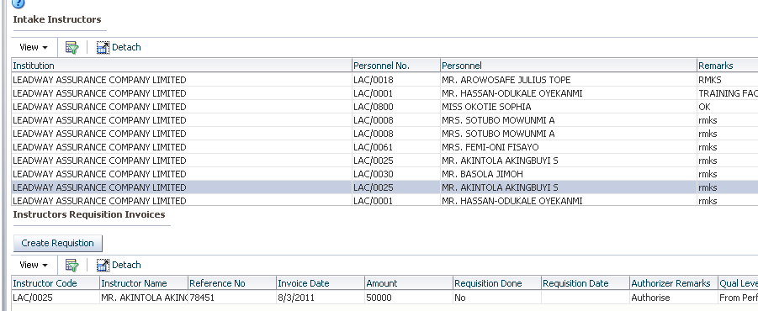

Select the intake instructor then select the invoice details and click **on **

### 2.9.3 Institutes Management

Used to define training institutes, their instructors and their costs

**Training Institute definition**

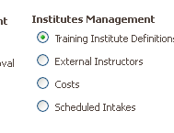>>>>>

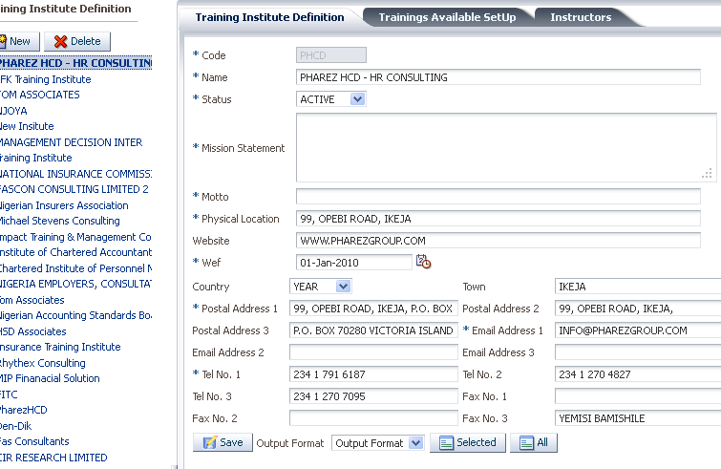

Use to define training institutes click on new record and give the following details

Code= short description of the institute

Name= full name of the institute

Status= define if institute is currently active or not

Mission statement=Give the mission statement of the institute

Motto= give the motto of the institute

Physical location= give the physical location of the institute

Postal address= give the postal address of the institution

Email address= give the institutions email address

Tel NO= Give the institutions telephone no.

**Click on the tab for training available setup the screen below is displayed**

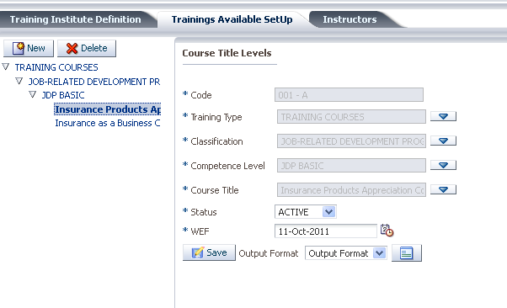

Click on new record and give the

Code= short description

Training Type= select training type from list of values

Classification= select classification from list of values

Competence level= select the competence level from the list of values

Course title= select the course title.

Status= select is the status is active or not

Wef= give the effective date and click on save.

**Click on instructor’s tab. the screen below will be displayed**

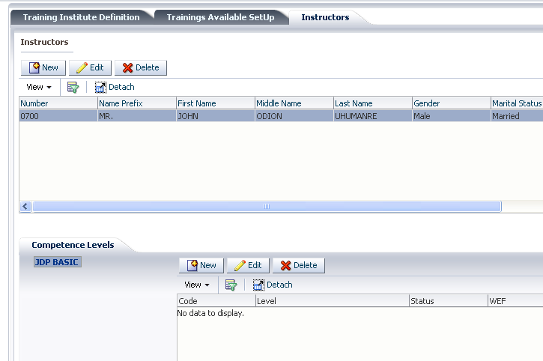

Click on new record to display the screen below

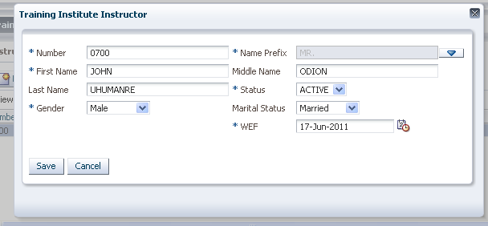

Number= give the instructors number

First name= instructors first name

Gender= instructors gender

Status= instructors status

Marital status= instructors marital status

Wef= effective date click on save to save record.

**Select instructor, select competency level and click on new to display the screen below**

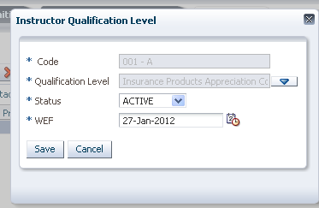

Code= short description of qualification level

Qualification level= full description of qualification level

Status= select if active or inactive

Wef= effective date

**External instructors**

Used to define external instructors

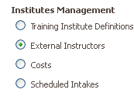>>>>>>>

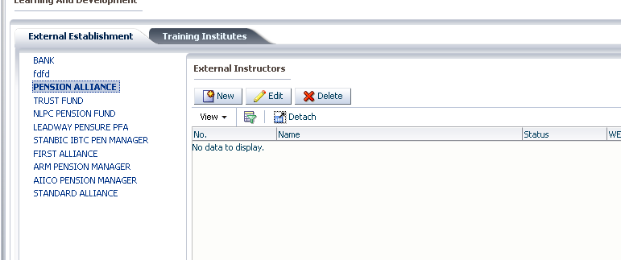

**On the external establishment tab select external establishment and click on new the screen below will be displayed**

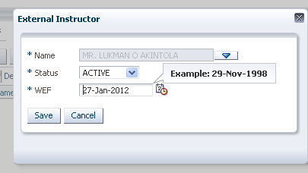

Name= select name of instructor

Status= select status if active or no

Wef = effective date

**On training institutes tab select training institute and click on new to display the screen below**

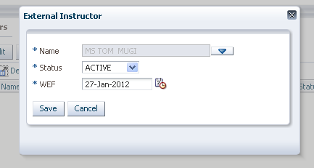

Name= select name of instructor

Status= select status if active or no

Wef = effective date

**Costs**

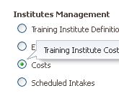**>>>**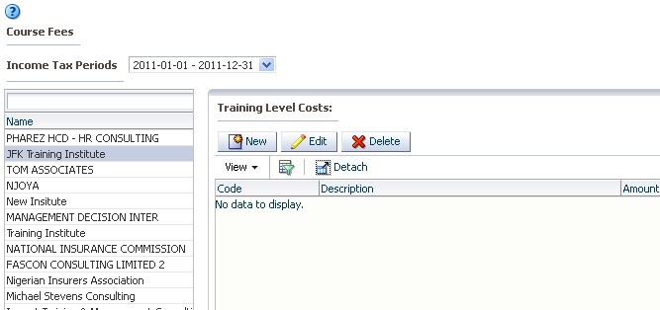

Select period institute and click and new to display the screen below

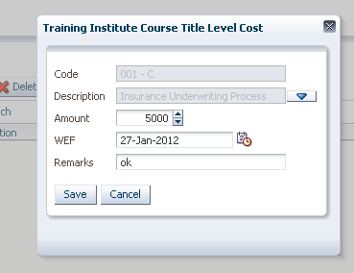

Code=short description of course title

Description= full description of course title

Amount= amount payable

Wef =effective date

Remarks= any remarks

**Scheduled courses**

Used for setting up scheduled courses per institution

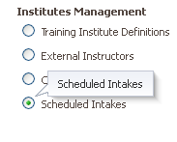>>>>> 

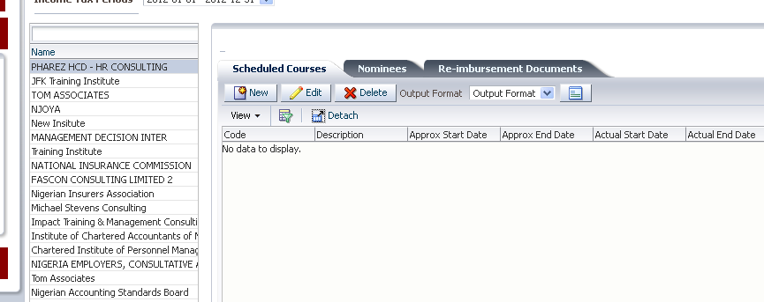

Click on new record on scheduled coursed tab to display the screen below

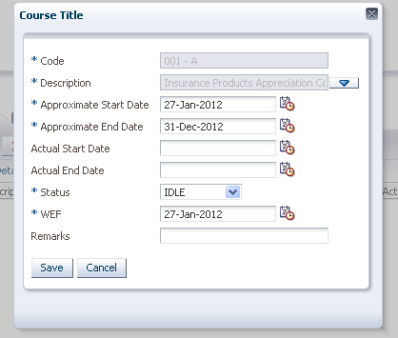

Code= short description of course

Approximate start date=Give the approximate date that you expect the training to start

Approximate end date=Give date you expect course to end

Wef = the with effect date from

Status= status of scheduled course.

**Click on the tab for nominees and click on new record to display the screen below**

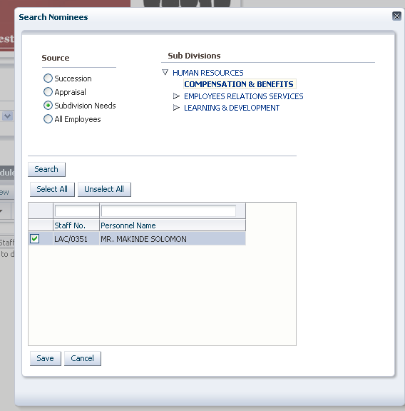  
Select the source e.g. subdivision needs

Select subdivision e.g. compensation and benefits

Click on search button to search for any existing record

Select personnel name and save.

**Click on the tab for re-imbursement documents and click on new record to display the screen below**

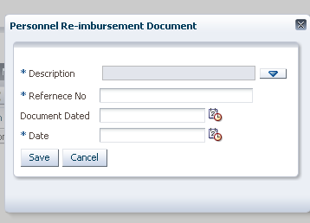

Select document description

Give document reference number

Give date of document

Give the date and click on save.

### 2.9.3 Training Directorate

**Training directorate definition**

Used for defining training directorate institutions.

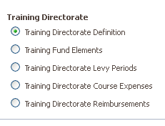>>>>> and click on new record to display the screen belo

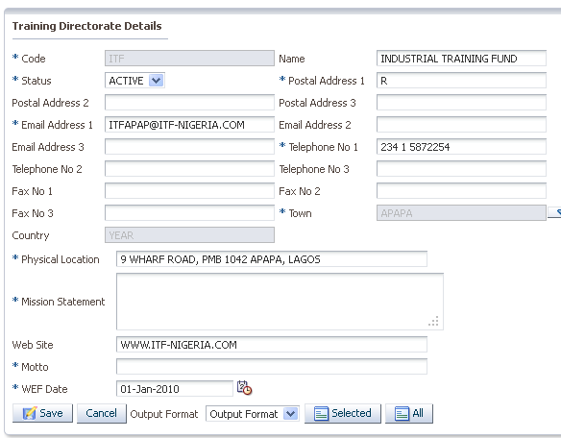

Code= short description of training directorate institute

Status= If it’s ACTIVE or INACTIVE.

Postal Address= give the institutes postal address

Email address= Give the institutes email address.

Telephone number= Give the institutes phone number.

Town=give the name of the town

Physical location= give the location i.e. where the institution is situated

Mission statement= Give the companies mission statement.

Motto= give the institutions motto

WEF= effective date

**Training Funds elements**

Used to define training funds pay elements

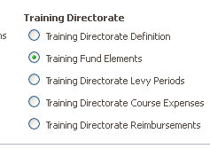 **>>>>>>**

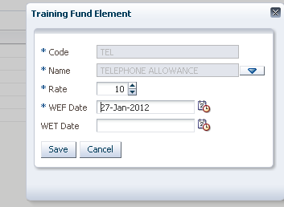

Code=short description of fund pay element

Name= full description of fund pay element

Rate= rate of fund pay element

Wef = effective date

**Training directorate levy periods**

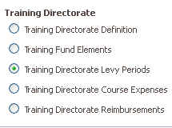>>>>> 

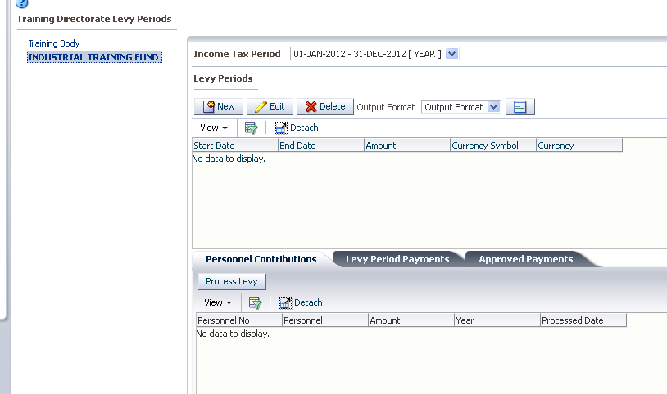

Select training directorate, select the period and click on new the screen below will be displayed;

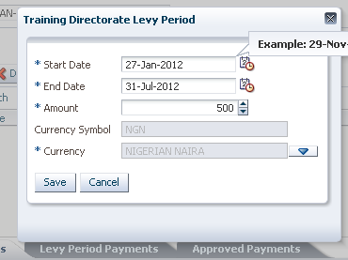

Start date=start date for levy period

End date= end date for levy period

Amount= amount applicable to the levy period

Currency= currency that will be used to make payments

Select levy period defined and on the tab for personnel contribution you can select the contrubition and click on 

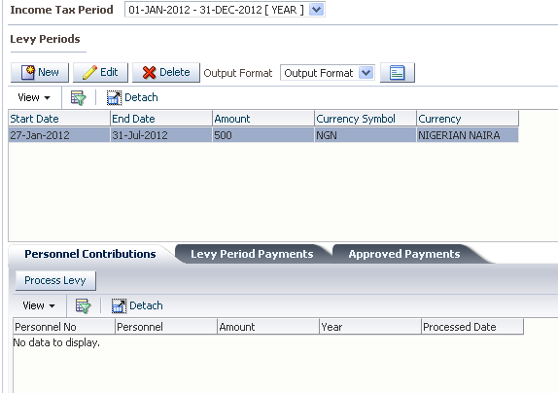

Click on levy periods payments and click on new record to display the screen below

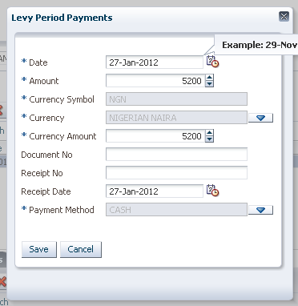

Date= give date of processing

Amount=amount to be processed

Currency=currency for making payments

Payment method= method to be used

Click on save record and then click on 

**Training directorate course expenses**

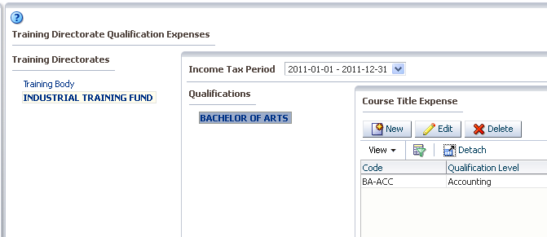

Selectperiod, select training directorate; click on new to display the screen below

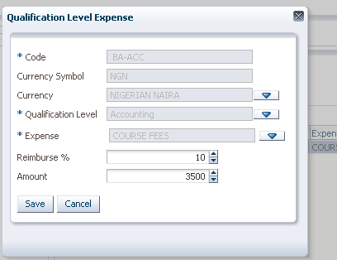

Code=code for currency

Qualification level= level of qualification being paid for

Expense= the type of expenses

Reimburse= %reimbursable

Amount= total amount

**Training directorate reimbursements**

Used to setup any reimbursements that will be reimbursed to the training directorate

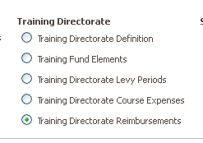 **>>>>>**

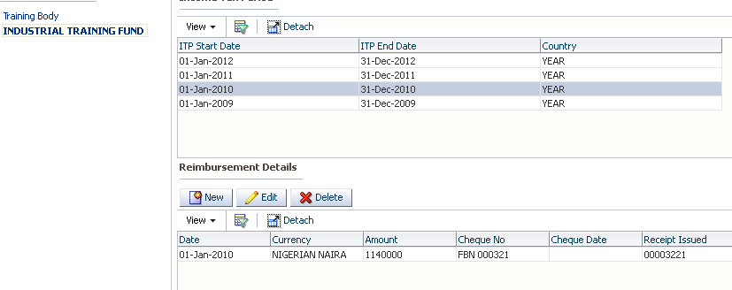

**Select training directorate select period and click on new record**

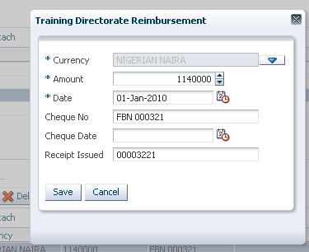

Currency=select currency o be used

Amount= input amount

Date=input the date

Cheque no= input the cheque number

Cheque date=input cheque date and click on save

## 2.10 DISEGAGEMENT

### 2.10.1 Pay elements

Used to define pay elements to be paid to personnel when they are leaving the company

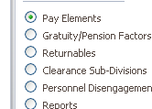>>>>

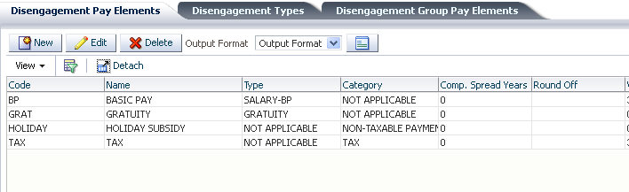PERSONNEL DETAIL**Click on the tab for disengagement pay elements and click on new to display the screen below;**

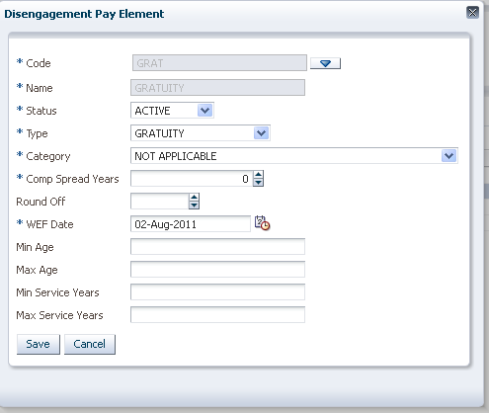

Code= short description of pay element selected

Name= full name of pay element selected from the list of values

Status= whether the pay element is active or inactive

Type= select the type of payment from a list of values i.e. gratuity, notice pay or pension

Category= the category of pay element i.e. contribution, deduction, tax etc.

Comp spread years= the number of years the compensation will be spread

Wef = effective date

Min Age= minimum age applicable

Max age= maximum age applicable

Min Service years=minimum number of service years

Max service years= maximum number of service years

**Disengagement Types**

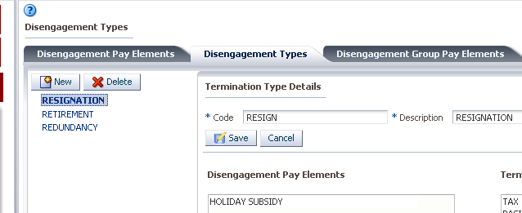

Click on disengagement tab and click on new record to display the screen below

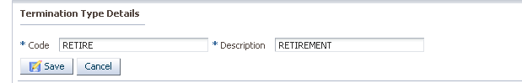

Give the code and description of the termination type and click on save.

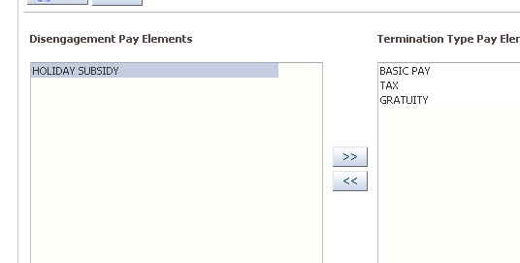

On the disengagement type defined assign the pay elements applicable to that disengagement type

**Disengagement Group pay elements**

Used to assign disengagement pay elements to groups

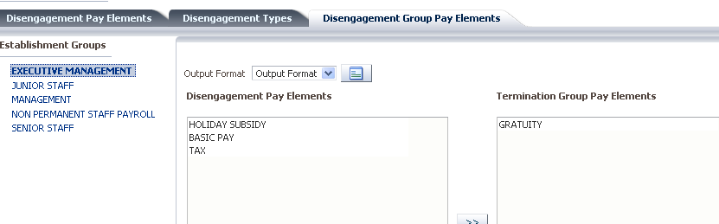

### 2.10.2 Gratuity pension/factors

Used To Set Up Gratuity and Pension Factors to Be Used In Calculating Dues Payables

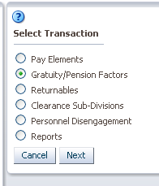 >>>> 

**Gratuity factor**

On gratuity factor tab click on new record to display the screen below

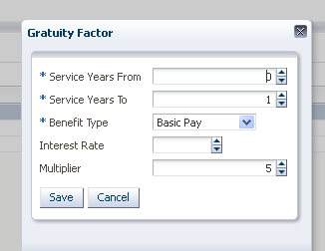

Define the service years from= the number of years the from which the gratuity factor is applicable

Define the service years to= maximum service years that the gratuity factor defined is applicable to

Benefit type= select benefit type applicable

Interest rate = any interest rate applicable in case the benefit is spread over a number of years

Multiplier= the multiplier to be used in calculating the gratuity and click on save.

**Pension/ gratuity factor**

Click on new record to display the account below

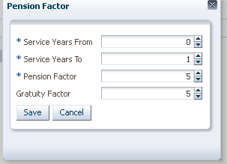

Define the service years from= the number of years from which the pension factor is applicable

Define the service years to= maximum service years that the pension factor defined is applicable to

Pension Factor= Give the pension factor and click on save.

### 2.10.3 Returnables

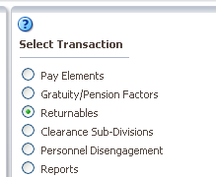**>>>>> **To display the screen below

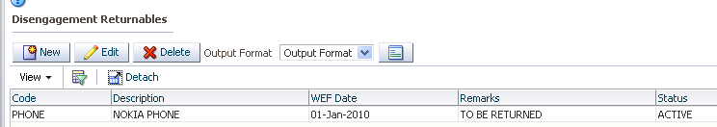

Click on new record to display the screen below

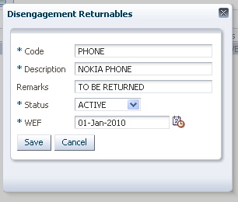

Code= short description of disengagement returnables

Description= Give the description

Remarks= give the remarks

Status= give the status

Wef= give the wef date and click on save.

### 2.10.4 Clearance Subdivisions

Used to define subdivisions and the returnable’s that will be returned during disengagement

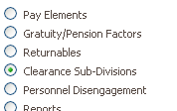>>>> 

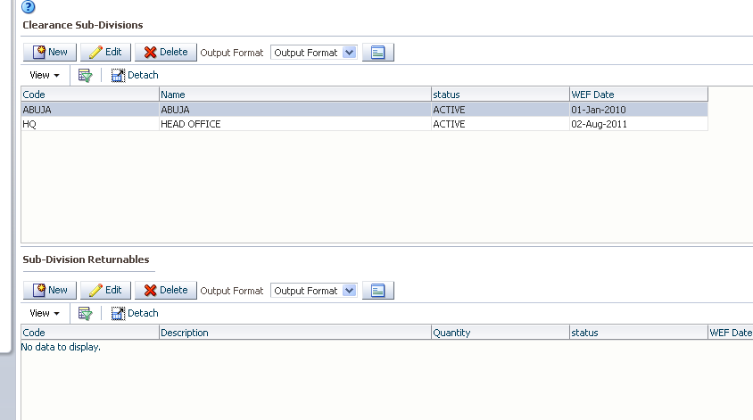

Click on new record to dsplay the screen below

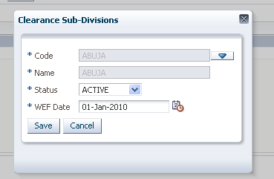

Code=short description of clearance subdivision

Name= description of clearance sub division

Status= either active or inactive

Wef= effective date

Select the clearance subdivision defined and go to 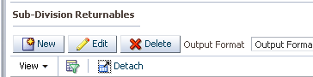

Click on new record to display the screen below

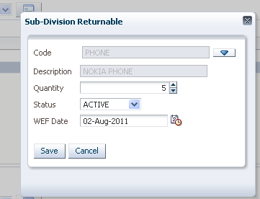

Code= Give the short description

Description= give the full description

Quantity=Give the quantity

Status= SAY whether the status is active or active

WEF =Effective date

### 2.10.5 Personnel disengagement

Used to define and process all payments that are payable to an employee who is being disengaged from the company

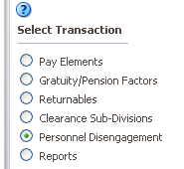>>>>>  and click on new record to display the screen below

**Personnel Disengagements**

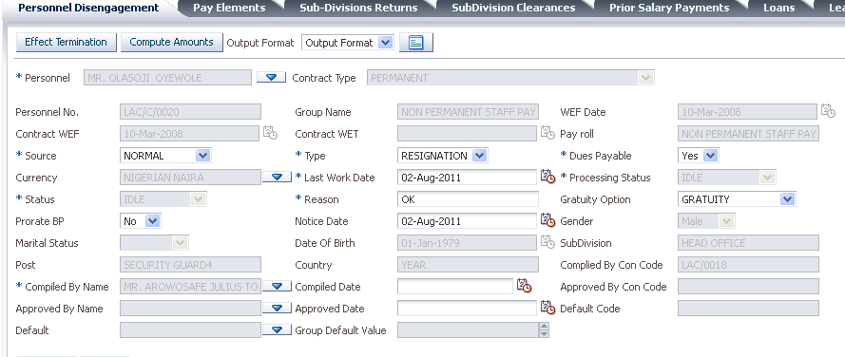

Personnel= select the name of the personnel being disengaged

Source= select the source of the disengagement

Type= select the disengagement type

Due payables= select if there are any dues payables to the employees

Currency= select the currency to be used in making the payables

Last working date= give the date of the last working day of the employee

Reason= Give the reason for disengagement

Gratuity option= select the gratuity option to be used for the dues payable

Complied by =select the name of the person who compiled the disengagement record

Complied date= give the date of compiling the records

Approved by= name of the person who approved the record

Approved by date=date the record was approved

Default=select the default value

Group default= select the group default value and click on save

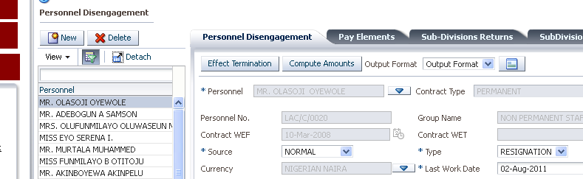

Select the record save and click on compute amounts and effect termination to terminate employee.

**Pay elements**

Will show you any pay elements computed and any additional pay elements payable to the employee

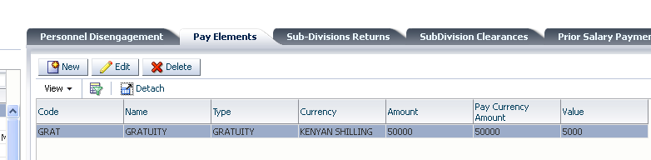

Pay element spreads can be show after selecting pay element payables and going to >>>

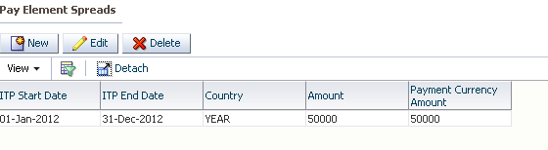

**Subdivision returns**

Used to capture subdivision returns for employee

Click ne w to create subdivision returns header

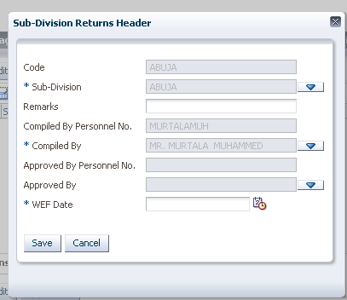

Code=short description of header

Sub-divisions= description of subdivision

Compiled by=select the name of the person compiling the return

Wef date=Effective date and click on save.

**Select subdivision header defined and click on new record 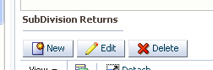 to display the screen** **below**

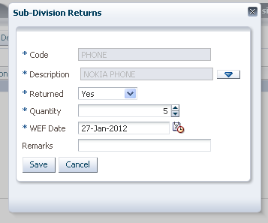

Code= shot description of return

Returned= if the item has been returned

Quantity= quantity of items returned

WEF= Effective date

**Subdivision clearance**

Used to capture details of subdivision clearance click on new record to display the screen below

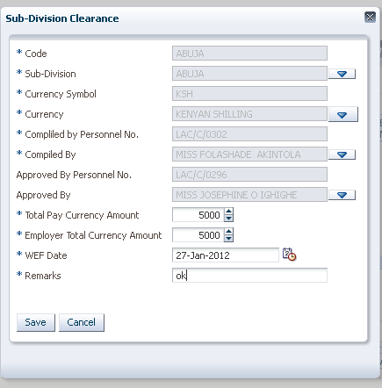

Code= short description of subdivision

Sub-division= full description of subdivision

Currency Symbol= currency symbol for currency to be used

Compiled by= name of individual compiling the returns

Approved by =name of personnel approving the return

Total pay currency amount= total currency amount payable for returnable

Wef date=effective date

Remarks =any remarks and click on save

Any clearance dues should also be captured in the screen above. This include any pay elements payable to the employer for clearance during disengagement.

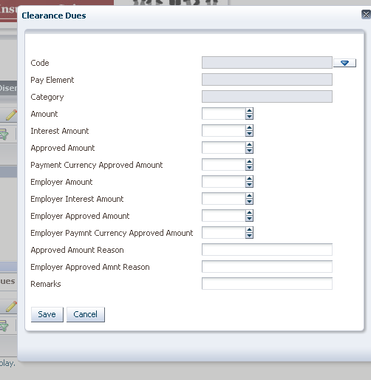

**Prior salary payments**

Any prior salary payments payable to the personnel should be captured on the screen below

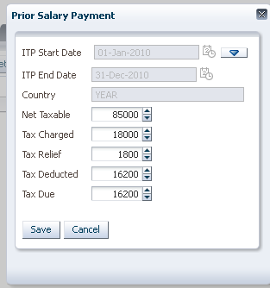

Select the period applicable, give the net taxable pay, give the tax charged, tax relief, tax. deducted and tax payable and click on save.

**Loans**

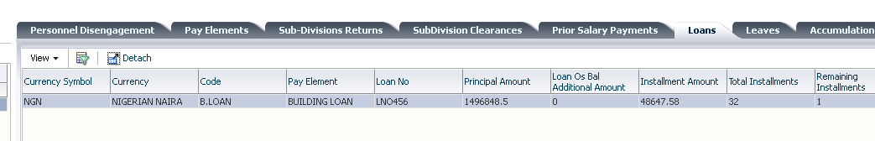

Any loan accumulations should be shown on the screen above

**Leaves**

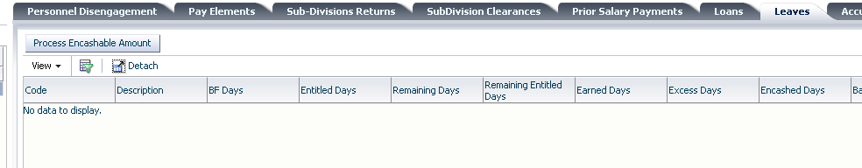

Anny leave accumulated and encashable should be shown on the screen above

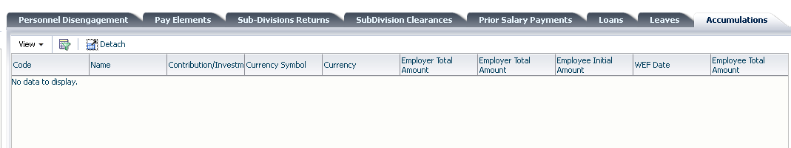

Any accumulations like pension will be should on the accumulations tab shown above

## 2.11 Letters and Memos

Used for creating standard letters and memos to be used in the organization

### 2.11.1 Create new

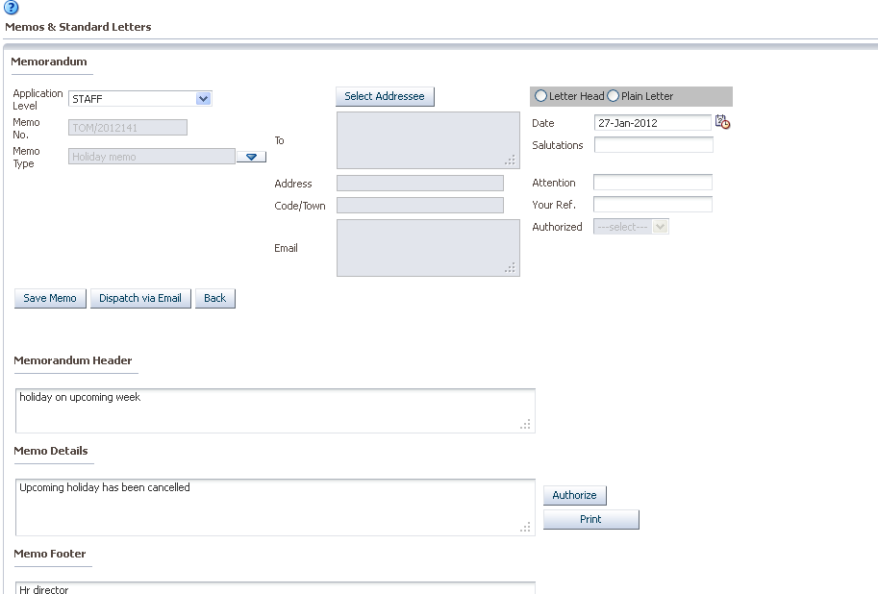

The memo should have the application level selected from already defined setups

Memorandum header also defined from already created setups but can be edited

Memo details defined from previous setups but can also be edited

Memo footer also o defined from previous setting but can be edited

The addresse can be selected from a list of values as shown below

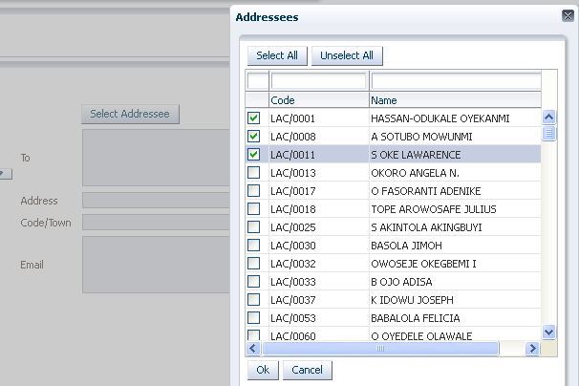

You can choose to add letter heads, dates, salutations, attention your ref and authorizer as shown below

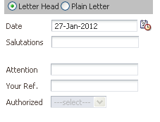

The letter can be saved or printed as a report from the below icons.

You can also create a new letter.



Memo can also be saved or dispatched via email as shown above

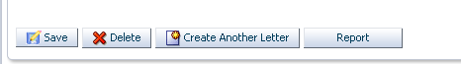

### 2.11.2 Edit un_ authorized

Unauthorized letters can be edited . 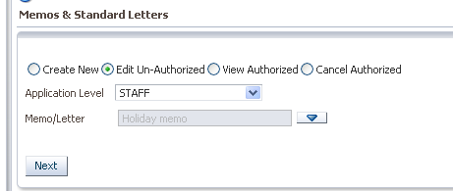>>>>> 

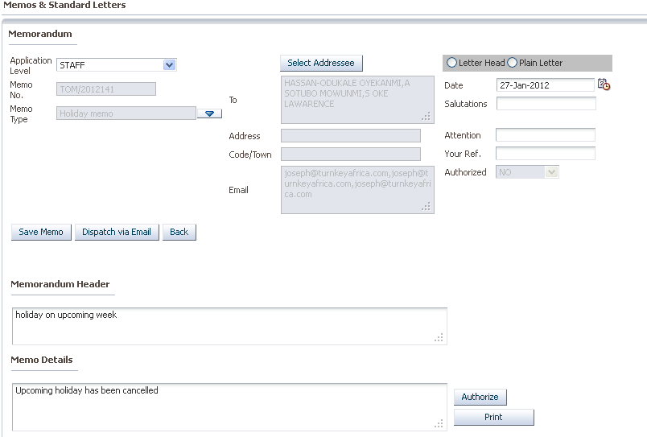

### 2.11.3 View authorized

Authorized memos can be also be viewed

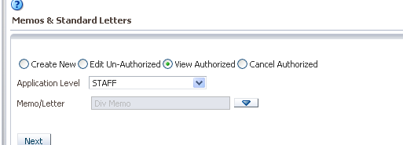 >>>>

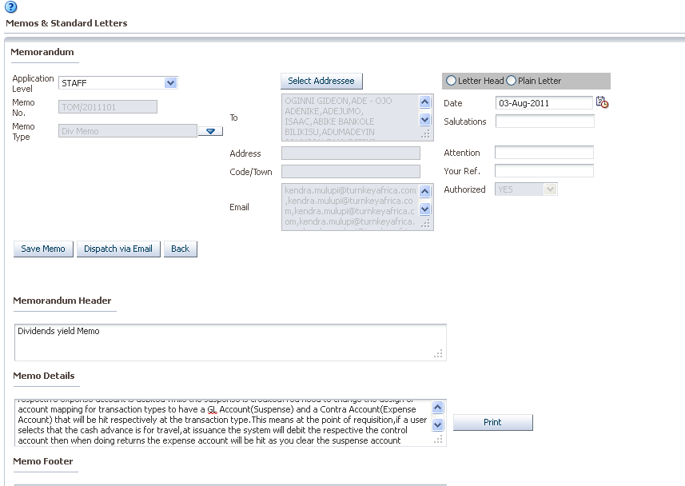

### 2.11.4 Cancel authorized

Authorized memos can be cancelled .

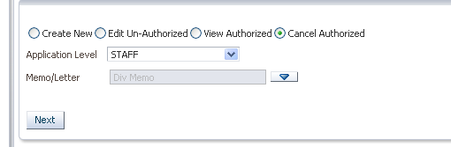

>>>>>>>>

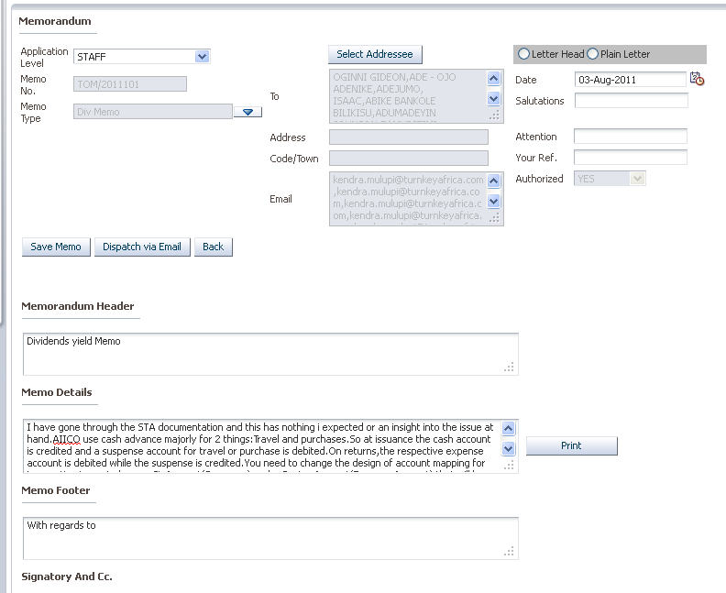

# 3. PAYROLL

Used to define and run payroll and loans

## 3.1 MASTER DEFINITION

Used to define the setups for different types like salary, overtime

**Home >> payroll >> master definition**

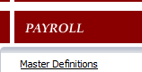

### 3.1.1 ESTABLISHMENT DEFAULTS

**Home >> payroll >> master definition>> establishment**

To define this setups at establishment level

To create a new one click on the **establishment defaults tab**

>> select >>

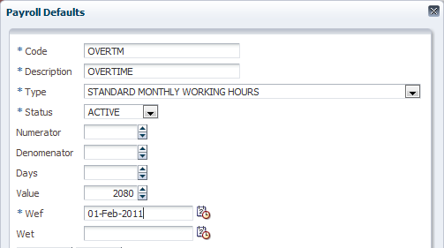

This is to define a **setup** for **over time,**

Type = select specific type from the LOV.

Status = if it should be active

Value = for overtime, this value is the **total working hours** in a **year**

And 

### 3.1.2 GROUP DEFAULTS

After defining the **establishment defaults,** it is possible to set **by groups**

**Home >> payroll >> master definition>> group defaults**

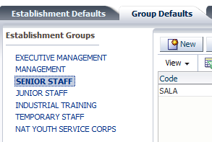**>>**highlight the group>>

Select >>

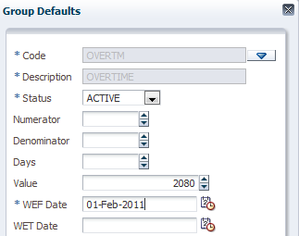

Code = code that is picked from the **establishment default**

Status = if active or not

Value =the value is auto populated upon picking the **code**

And 

### 3.1.3 PAY POINTS

**Home >> payroll >> master definition>> pay points**

Used to define the various pay points: click the **pay points tab**

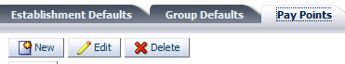>> select >>

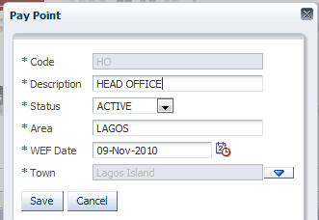>>>>

## 3.2 PAY ELEMENTS RATES

Used to define **rates tables** for those pay elements that were defined as having a **rate table** when defining the **pay elements.**

**Home >> payroll >> pay elements rates**

First, create a **pay elements rates table header**

**>>**select >>

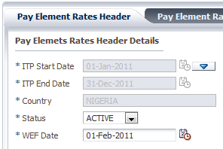

**ITP =** income tax period start date. Picked from a LOV ()

**Status** = active or not active

**WEF**= with effect from

And  .

To capture **rates table** for pay elements with **rates table**

Highlight the **rates header** just defined

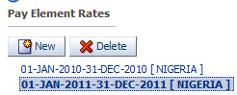**>>**Move to the right and >>

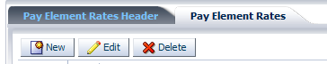>> select >>

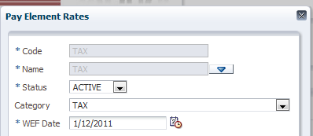

Name = it is picked from an LOV of pay elements define as having rates table

Status = if it is active

Category = the category the pay element belongs to





Now to capture the **rates details,** highlight the pay element >>

>> select >>

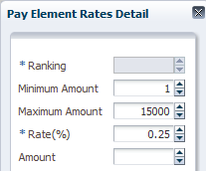

Minimum amount = the minimum amount like a range from

Maximum amount = the maximum amount like a range to

Rate = the rate set for a gross net pay elements within the range of minimum and maximum amount

And 

### 3.3 PERSONNEL PAYMENT DETAILS

Used to capture payment details of each employee

**Home >> payroll >> personnel payment details**

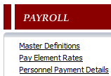

Highlight the **personnel**

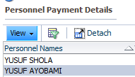**>>**

**Bank branches = >>>>**

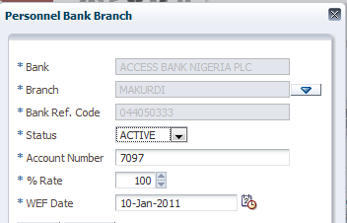**>>**

Branch = the bank branch for that personnel

Status = if active

Account number = the account number for that personnel in the bank

Rate = what % of his salary should go there

And.

**Pay points =**click **>> select**>>

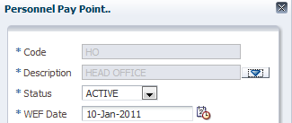>>

Description = the point that he/she can pick his money

Status = if active

>>

**Pay currencies =  = currency** in which to pay personnel:

Select >>

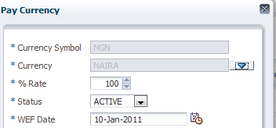

Currency = the currency to pay personnel

Rate = how many percentage of his salary should be paid in this currency

And .

**Pay methods** =  to define the payment method to pay the personnel

Select >>

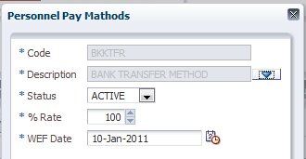

Description = the type of payment method

Status = whether active

Rate = percentage of his salary to be paid in this payment method

### 3.5 PERIODIC TRANSACTION

Used to capture details of **pay elements** that are Once periodic**.**

**Home >> Payroll >> periodic transaction**

### 3.5.1 PAY ELEMENT WISE

Used to capture details from the **pay element point of view**. Pick the **radio button**

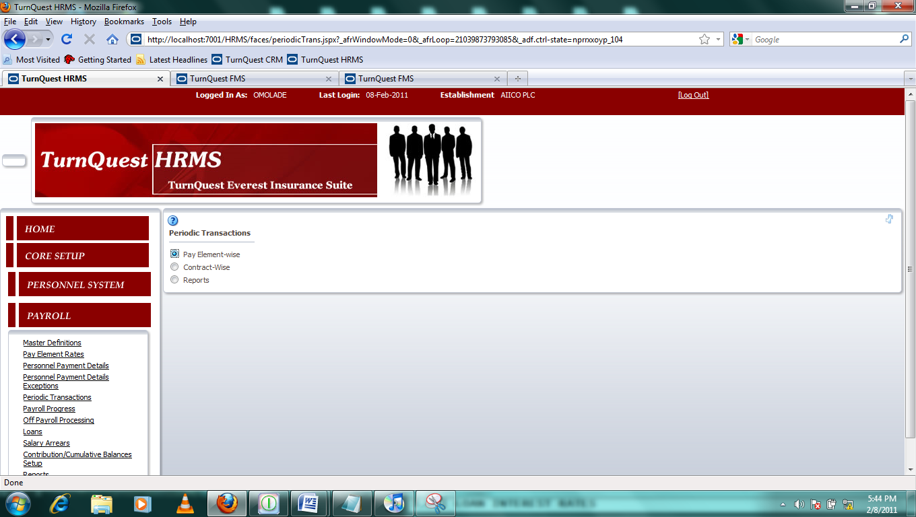>>

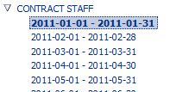Drop down arrow to pick the period to input value for

>> on the right hand side

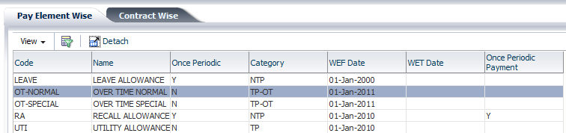

Highlight the **pay element,**

Below, click the **periodic transaction tab >>select >>**

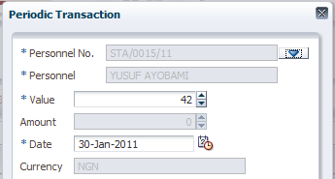

**Personnel no =** to pick the personnel

**Value** = to input the value (which can range from **overtime** to **pay elements** that just need their amounts)

And 



### 3.5.2 CONTRACT WISE

Used to capture values from the contracts point (from the personnel’s)

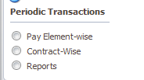>> pick the radio button for **contract wise >>**

****Drop down arrow to pick the period to input value for

On the **contract wise tab,** highlight the personnel

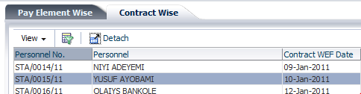**>>**

The **periodic transaction tab** below >>>> select >>

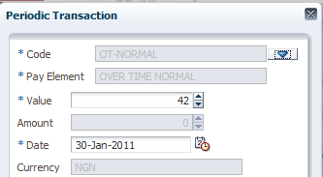

Code = unlike the **pay element wise,** the pay element is picked from **LOV**

Value = the value is picked

Date = date

And  .

**3.5.3 REPORTS**

To run reports on the periodic transactions

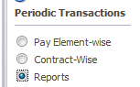 Pick the radio button >>

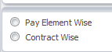 Pick the radio button of the report to run

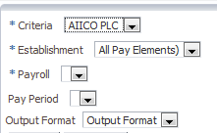

Establishment= the organization

Criteria = whether all pay elements or one pay element

Pay roll = pick the payroll to run

Pay period = pick the period

Output format = the format the report should spool out

 = to generate the report

## 3.6 PAYROLL PROGRESS

Used to run the payroll, pay slips and authorize

Home >> payroll >> payroll progress

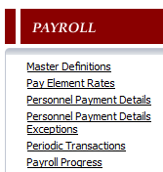

### 3.6.1 PRE-PROCESSING

Pre-processing enables preparation of payroll for processing by highlighting mistakes and omissions.

>>>>

Highlight the payroll

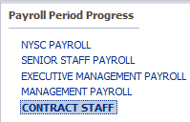>> highlight the period to process



And click 

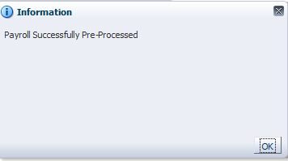

### 3.6.2 PROCESSING

Used to **process** the payroll after it has been **pre-processed**

**>>>>**

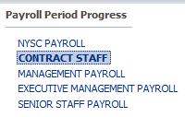Highlight the **payroll >>**



Highlight the period to **process >>**

### 3.6.3 ROLLBACK

Used to roll back a processed payroll incase of any mistake

>>

>> highlight the period to process





### 3.6.4 AUTHORIZATION

Used to authorize payroll after confirmation of the payroll.

>>

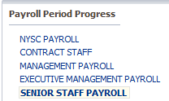 Highlight the payroll >>



Highlight the period to authorize

And 

### 3.6.5 PAYSLIP INQUIRY

Used to view pay slips

>>>>

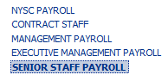 Highlight the payroll

Then click  to generate >>

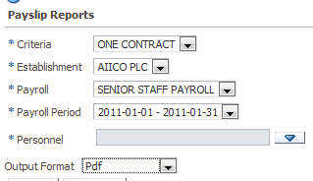

Criteria = one contract, al contracts

Establishment = the organization

Payroll = the payroll to run

Payroll period = the period

Personnel = the personnel

Output = the output of the report

 To run report

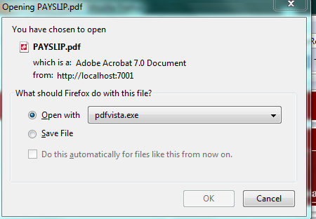

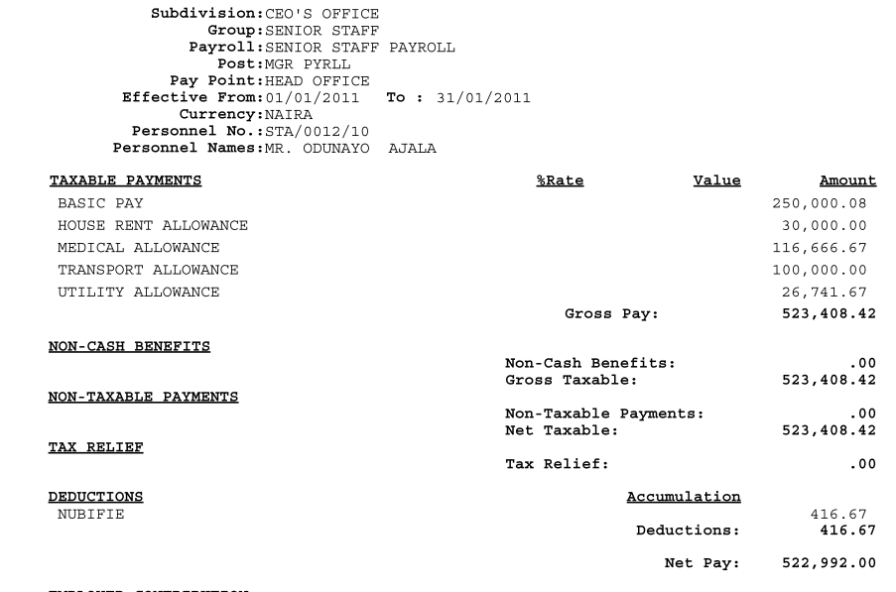

### 3.6.6 EMAIL PAYSLIPS

Used to email pay slips to personnel

>>>>

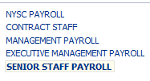 Highlight the payroll >>



Highlight the period

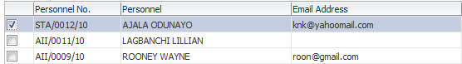

Pick the check box of personnel to send email

And click

### 3.6.7 REPORTS

Used to run different reports

>>>>

 Pick the report to run >>

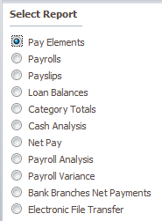 Pick a report >>>>

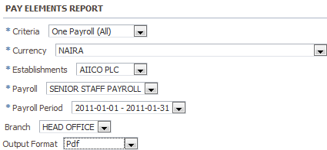

Criteria = the criteria.

Currency = the currency

Establishment = the establishment

Payroll = the payroll

Branch = the branch

Output format = the format the report should run

 = to generate the report

## 3.7 OFF PAYROLL PROCESSING

Used to process pay elements that are pay elements that are not processed on the normal payroll. (En-block pay elements)

Home >> payroll >> off payroll processing

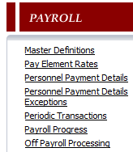

### 3.7.1 EN BLOCK PROCESSING

This is used to process en-block payments

>>>>

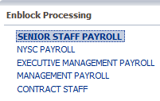 Highlight the payroll >> on the right hand side



Highlight the period

Below, on the **pay element tab,** 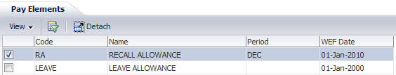

Tick the check box of the pay element to be processed>>

And click  = to process en-block payments

### 3.7.2 ROLLBACK ENBLOCK

This is used to roll back to correct mistakes and process payroll again.

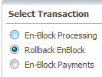>>>>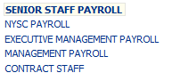 highlight the payroll

On the right hand side >> highlight the period



And  = to roll back

### 3.7.3 EN-BLOCK PAYMENTS

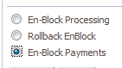**>>>>**

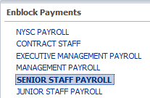Highlight the payroll>>

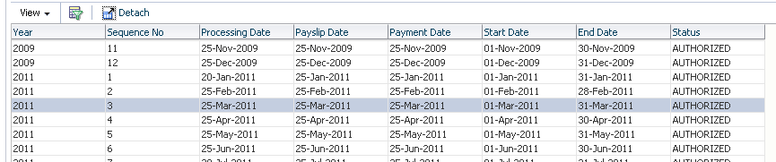>> highlight the period select pay element as shown below input the processing date and click on process

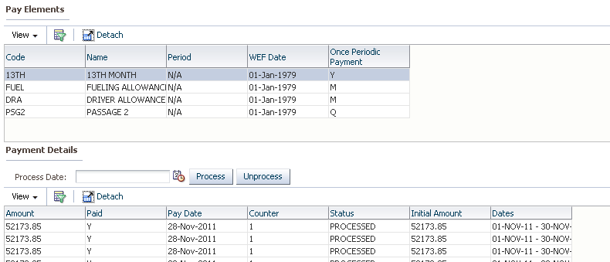

### 3.7.4 EMAIL EN-BLOCK PAYSLIPS

>>>>>

Highlight payroll as shown below

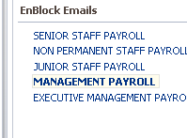

Select period and pay element to email as shown below

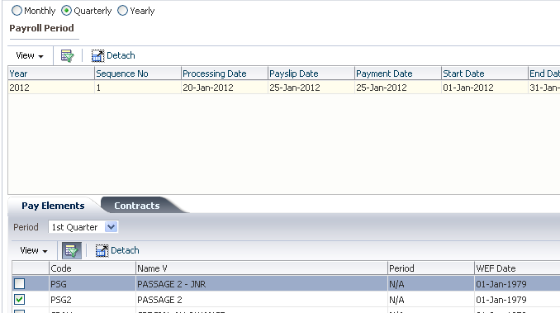

Make sure u select the period and the pay element and then click on the contracts tab

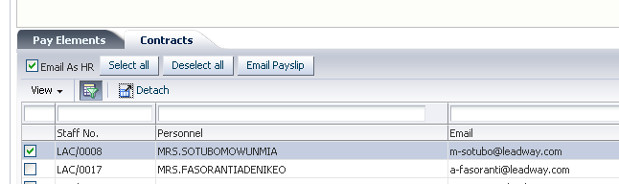

Select the name of the personnel to email and click on 

## 3.8 LOANS

This is used in setting up loan interest rates, view loan settlement and reports

Home >>payroll >> loans

### 3.8.1 LOAN INTEREST RATES

This is used in setting up loan interest rates for government and establishment

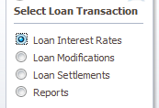>>>>

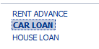 Highlight the loan which is auto populated after it was defined from the pay element

Click the **establishment loan interest rate tab**to set the interest rate for the establishment

>> select >>

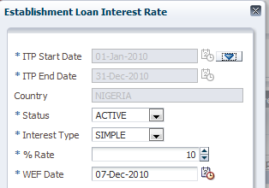>>

ITP start date (income tax period) = to pick the start date

Interest type = to pick the interest type

Rate = the rate defined by the establishment

To setup **government rate,** click on the tab

**>>>>**

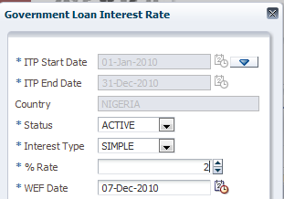**>>.**

## 3.8.3 EXTERNAL LOANS APPLICATIONS

Used to capture external loans

>>>>>

Select the name of the employee and click on new

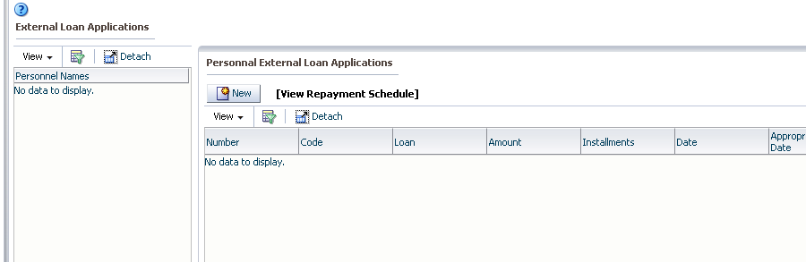

## 3.8.4 LOAN MODIFICATIONS

This is used to modify loans that are in progress

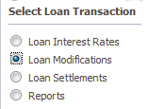**>>**

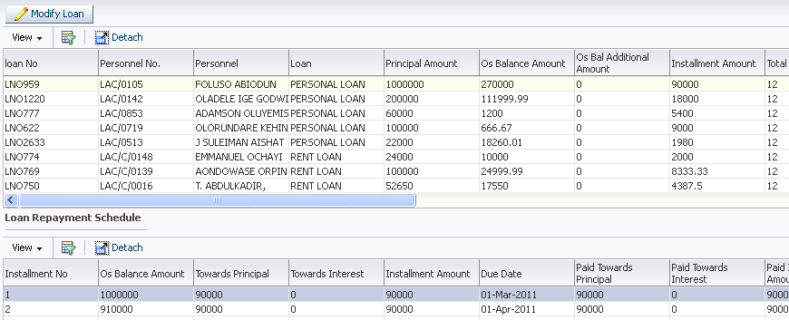**Select the loan to be modified and click on modify to display the screen below**

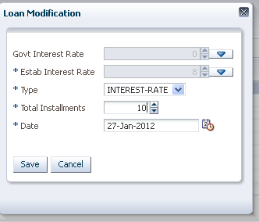

Input the new interest rate, select type f modification, total instalments and date and click on save.

Modified loans tab is used to view any loans that have been modified

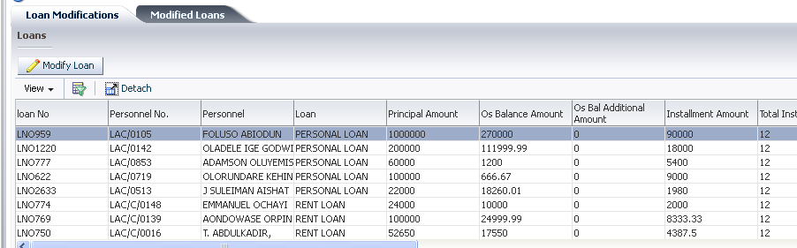

## 3.8.5 LOAN SETTLEMENTS

Used to settle loans

>>>>>>>

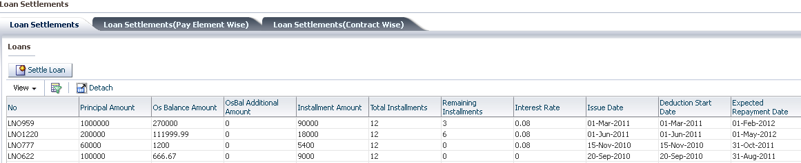

Select the loan to be settled and click on settle loan to display the screen below

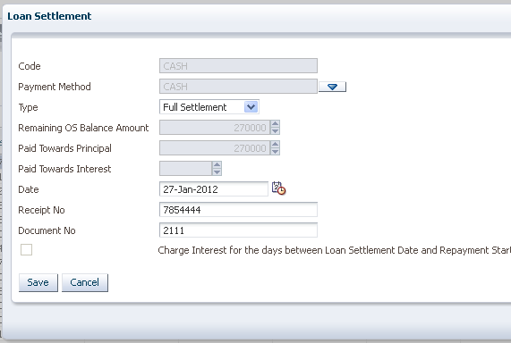

Select the payment method

Select the payment type

Input the date

Input the receipt number

Input the document number and click on save.

**Loan settlement (pay element wise)**

Used to view all loan settlements done per pay element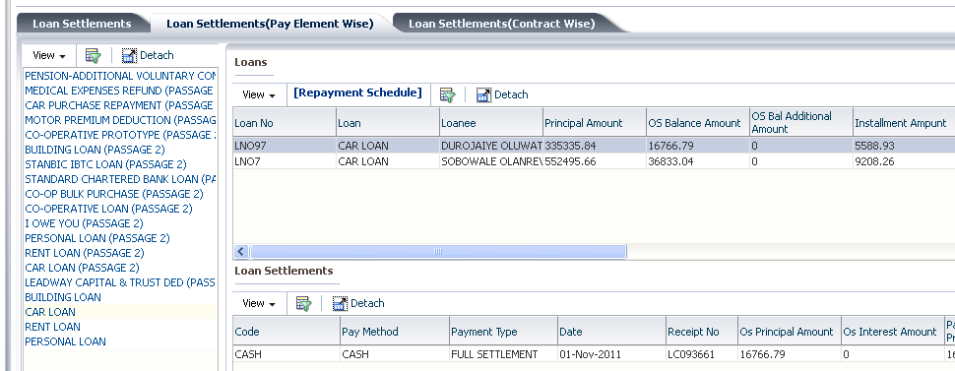

**Loan settlements (contract wise)**

Used to view any loan that have been settled per contract

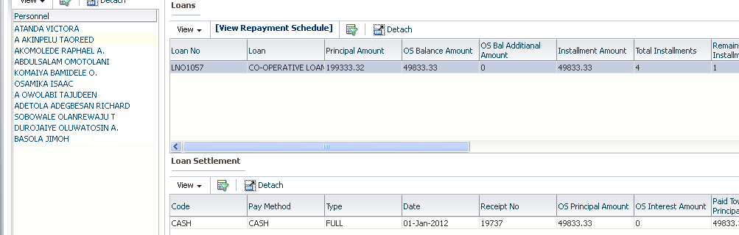

### 3.8.6 REPORTS

Used to run reports

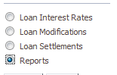>>>>

## 3.9 SALARY ARREARS

Used in setting up and processing salary arrears

Home >> payroll >> salary arrears

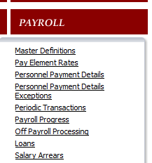

## 3.9.1 PAY ELEMENTS

Used to define the pay elements that will be paid on salary arrears

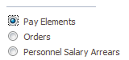**>>>>**

**>> select >>**

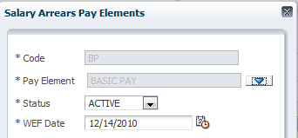

**Pay element =** to pick the pay element

**Status** = active

**And **

## 3.10 CONTRIBUTION/CUMULATIVE BALANCES

This is used to view all contribution and cumulative balances per personnel per pay element

Home >> payroll >> contribution/cumulative balances

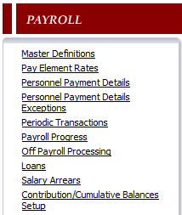>>

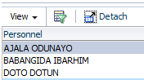pick the personnel >> on the left-hand side >>



**NOTE: the pay elements that are viewable are either cumulative or a contribution**

Highlight the pay element

There are two tabs below

Click the >>



Employee amount = is the total amount the employee

Employer total amount = total amount of the employer